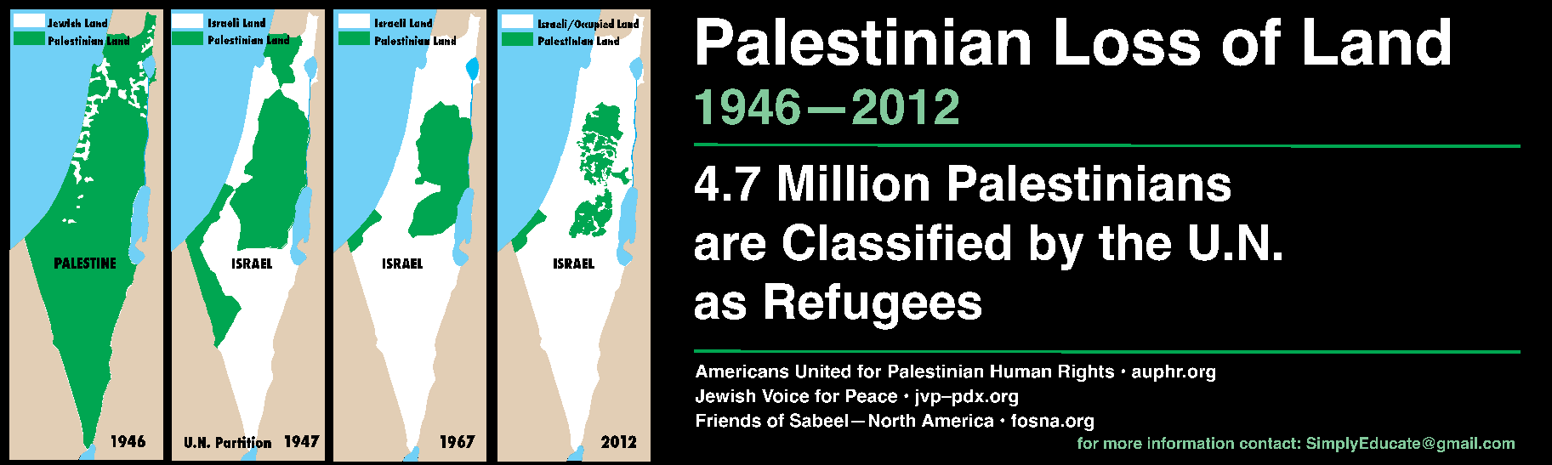
- Based on the document above, how did the Israeli-Palestinian conflict impact Palestinians?

- Taking on the role of a Palestinian, why would the 1947 U.N. Partition map upset you? Explain why.

- Taking on the roll of a Jew, why would the 1947 U.N. map upset you? Explain why.

- How does this document answer the DBQ question?

