Immigration of Jews to Palestine/Israel (1919-1970)
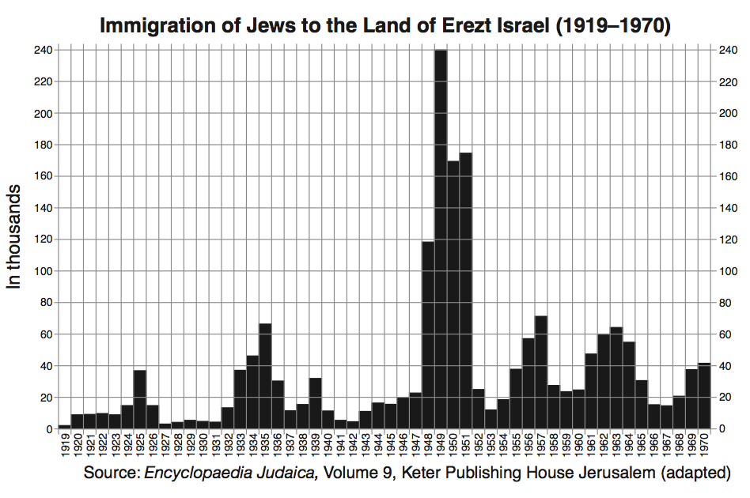
Document B2

- According to these documents, identify two specific reasons why large numbers of Jewish immigrants moved to the Palestinian/Israeli region between 1920 and 1970.

- Using both visuals, why do you think there was a large increase of Jewish people to Israel between 1947 - 1949?

- As the Jewish population in this area grew, what can you infer was the Palestinian reaction to this growth?

- How do these visuals relate to the Israeli/Palestinian Conflict?

