Governments of Africa | Kenya | Nigeria | South Africa
Flag (Color each flag) | 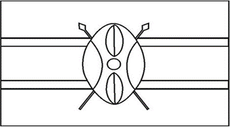 |  | 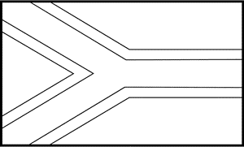
Type of Government:
Head of Government (Title and name):
How is the head of government chosen?
Duration of term for head of government:
Voting Rights:
 | Kenya | Nigeria | South Africa
Level of Citizen Participation (Choices: autocratic or democratic)

Additional Info (under “People and Society”): | Life expectancy rate: ___ years  Literacy rate: _______%  HIV/AIDS rate: _______% (number ______ in the world)  School Life Expectancy:  Total: ______ years  Male: _____ years  Female: ____ years | Life expectancy rate: ___ years  Literacy rate: _______%  HIV/AIDS rate: _______% (number ______ in the world)  School Life Expectancy:  Total: ______ years  Male: _____ years  Female: ____ years | Life expectancy rate: ___ years  Literacy rate: _______%  HIV/AIDS rate: _______% (number ______ in the world)  School Life Expectancy:  Total: ______ years  Male: _____ years  Female: ____ years

