Column 3: Ashanti  -*MUST include description of its location, religion, language, and at least 1 picture  - **Additional (must have at least 1) fact(s) about ethnic group. Below are some ideas:  customs, traditions, clothing, music, holidays, & art, important landmarks, places, or historical sites that people may want to visit |  | Back Column: Back Cover  -your name, date, class period  -picture(s)  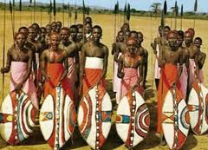 |  | Front Column: Title/Cover page  - an exciting phrase to catch people’s attention (TITLE)  - names of ethnic groups  -picture(s)  Title  -EG  -EG  -EG  -EG  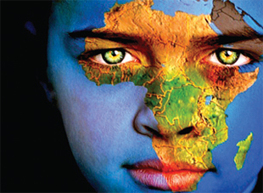

r
Column 2: Arabs  -*MUST include description of its location, religion, language, and at least 1 picture  - **Additional (must have at least 1) fact(s) about ethnic group. Below are some ideas:  customs, traditions, clothing, music, holidays, & art, important landmarks, places, or historical sites that people may want to visit |  | Column 5: Bantu  -*MUST include description of its location, religion, language, and at least 1 picture  - **Additional (must have at least 1) fact(s) about ethnic group. Below are some ideas:  customs, traditions, clothing, music, holidays, & art, important landmarks, places, or historical sites that people may want to visit |  | - Column 6: Swahili  - -*MUST include description of its location, religion, language, and at least 1 picture  - - **Additional (must have at least 1) fact(s) about ethnic group. Below are some ideas:  customs, traditions, clothing, music, holidays, & art, important landmarks, places, or historical sites that people may want to visit

