Governments of Africa | Kenya | South Africa | Nigeria
Flag | 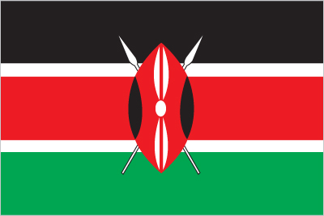 | 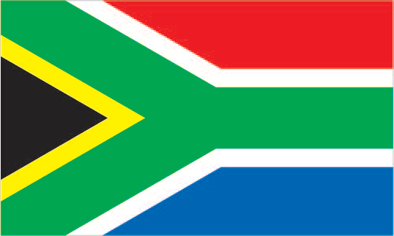
Type of Government: | Republic—Presidential democracy | Republic—Parliamentary democracy (with elements of presidential dem.) | Federal Republic—presidential democracy  (issues with corruption)
Level of Citizen Participation (autocratic, oligarchic, democratic): | Democratic | Democratic | Democratic
Head of Government (Title, Name, and Picture): | President Uhuru Kenyatta  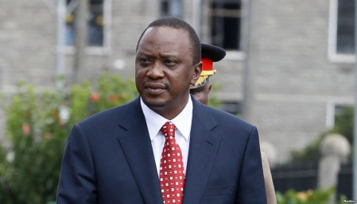 | President Jacob Zuma  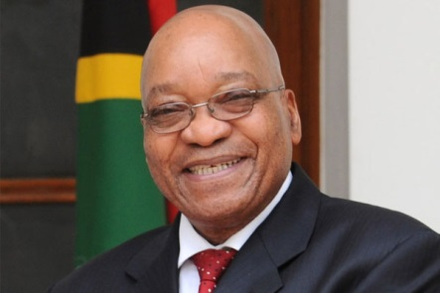 | President Major General Muhammadu Buhari  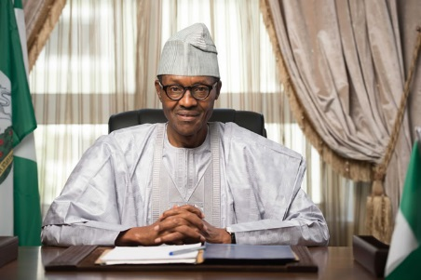
 | Kenya | South Africa
Chief of State (Title, Name, and Picture): | Same as head of government | Same as head of government | Same as head of government
How is the head of government chosen? | Elected by popular vote | Elected by National Assembly but serves as head of a separate executive branch | Elected by popular vote
Duration of term for head of government: | 5 year term (can serve 2 terms) | 5 year term (can serve second term) | 4-year-term (can serve 2 terms)
Voting Rights: | Universal suffrage at 18 years of age | Universal suffrage at 18 years of age | Universal suffrage at 18 years of age
Additional Info: Life expectancy rate, Literacy rate, HIV/AIDS rate | Life expectancy rate: 63.77 years  Literacy rate: 78%  HIV/AIDS rate: 5.3% (number 13 in the world) | Life expectancy rate:  62.34 years  Literacy rate: 94%  HIV/AIDS rate: 18.92% (number 4 in the world) | Life expectancy rate: 53.02 years  Literacy rate: 61.3%  HIV/AIDS rate: 3.17% (number 20 in the world)

