Name:___________

Date: ___________

Period: ____

Libya

Somalia

South Africa

Tanzania

Sudan

South Sudan

Egypt

Ghana

Kenya

Madagascar

Mozambique

Nigeria

Use pg. 122 in the atlas

***Label the following countries:***

Algeria

Central African Republic (CAR)

Chad

Democratic Republic of the Congo (DRC)

Ethiopia

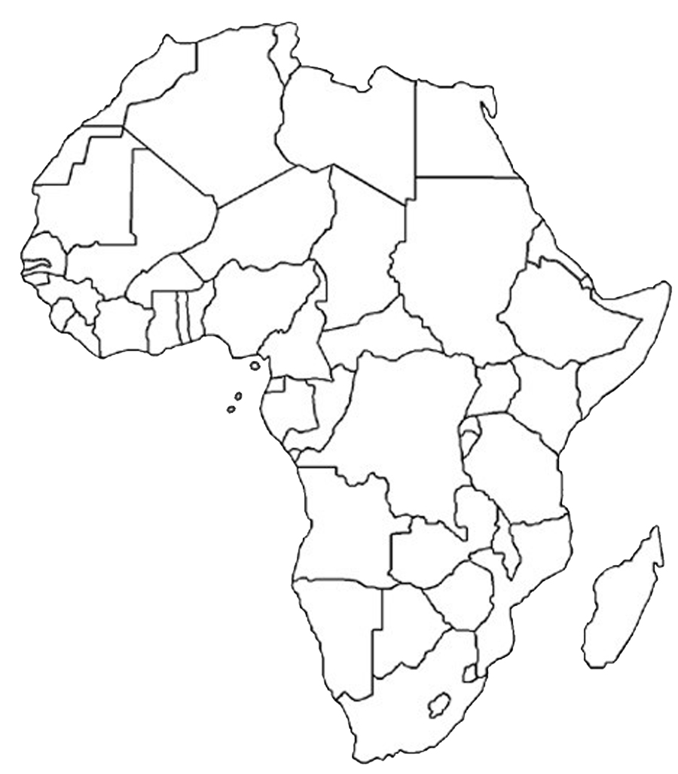

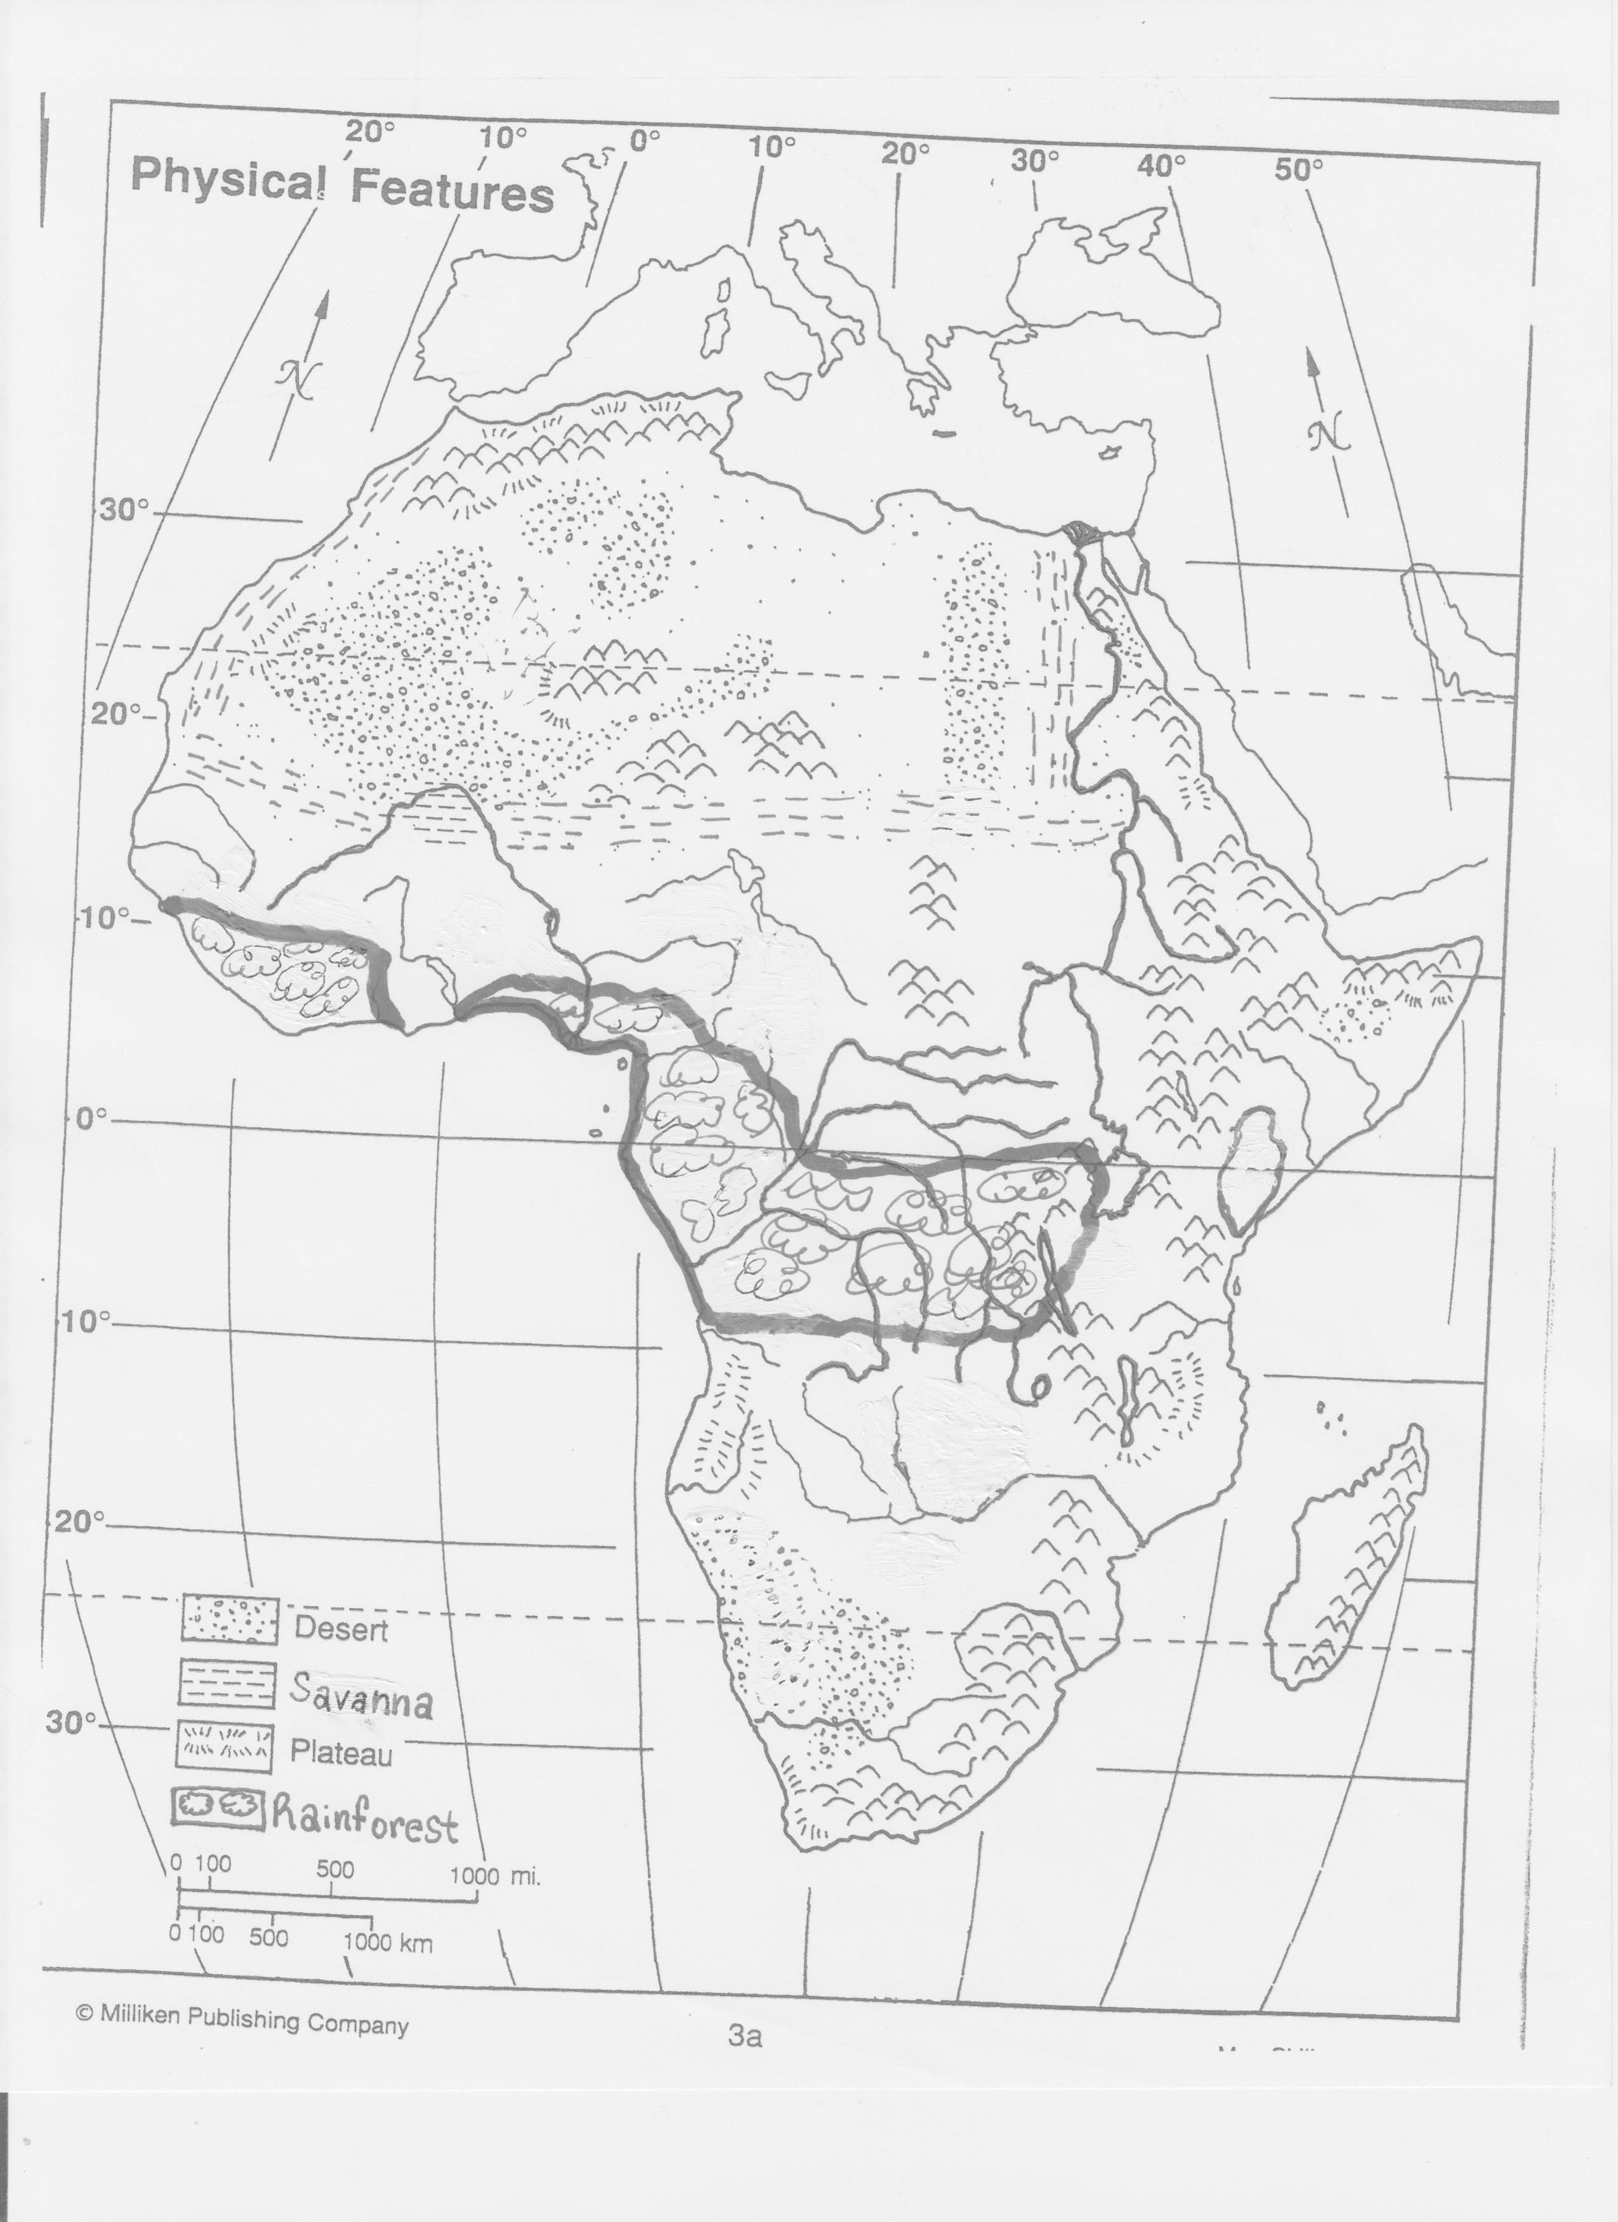

**You will label the Physical Features**

Sahara Desert

Kalahari Desert

Congo River

Niger River

Nile River

Great Rift Valley

Lake Victoria

Atlas Mountains

Mt. Kilimanjaro

Mt. Kenya

Sahel

Congo Rainforest

Savanna