ETHNIC & RELIGIOUS Groups Map
Name: _________________________
Date: _________________________
Period: ________________________

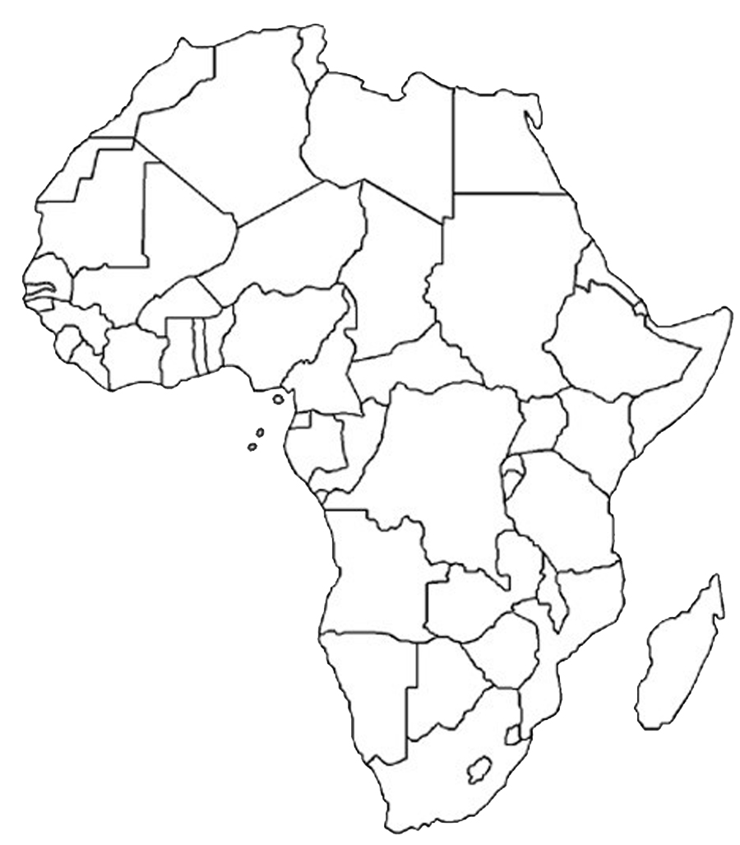
KEY
Ethnic Groups
Arab
Ashanti
Swahili
Bantu
Religious Groups
Christianity
Islam
Traditional Beliefs
1.Choose a color/pattern to represent each ethnic group. Add the colors/patterns to your key.
2.Color the areas on the map where each ethnic group is located.
3.Create a symbol to represent each religion. Add the symbols to your key.
4.Add the religion symbols to the areas of the map corresponding to the ethnic groups that practice it.

Africa’s Ethnic & Religious Groups

QUESTIONS Now that you’ve read and created a map and filled in your chart about Africa’s ethnic and religious groups, answer the following questions to see what you know.

- What is an Ethnic Group?

- What is a Religious Group?

- How did Christianity get to Africa?

- How did Islam get to Africa?

- How did traditional beliefs get to Africa?

- Describe two differences between Africa’s traditional religions and religions like
Christianity and Islam.

- How are Africa’s traditional religions similar to religions like Christianity and

Islam?

- Do people in the same ethnic group practice the same religion? Explain your answer and use two examples from Africa.

- Compare the ethnic & religious groups on your map to the current political borders for each African country. The current political borders for each country were drawn by European rulers (ex. British, French) who took over Africa in the 1800s. What potential problem do you see when you compare how the ethnic & religious groups are distributed to the political borders established by the Europeans? Give at least 2 examples from the map to support your answer.

Ethnic Group | Location | Language | Religion | Other Facts
Arab
Ashanti
Bantu
Swahili
Name:
Class Period:
Read Africa’s Ethnic & Religious Groups to find out where each ethnic group lives in Africa, what language they speak and what religions they practice. Record the information in the chart below.

Africa’s Ethnic & Religious Groups Activity

