CARTOON 1
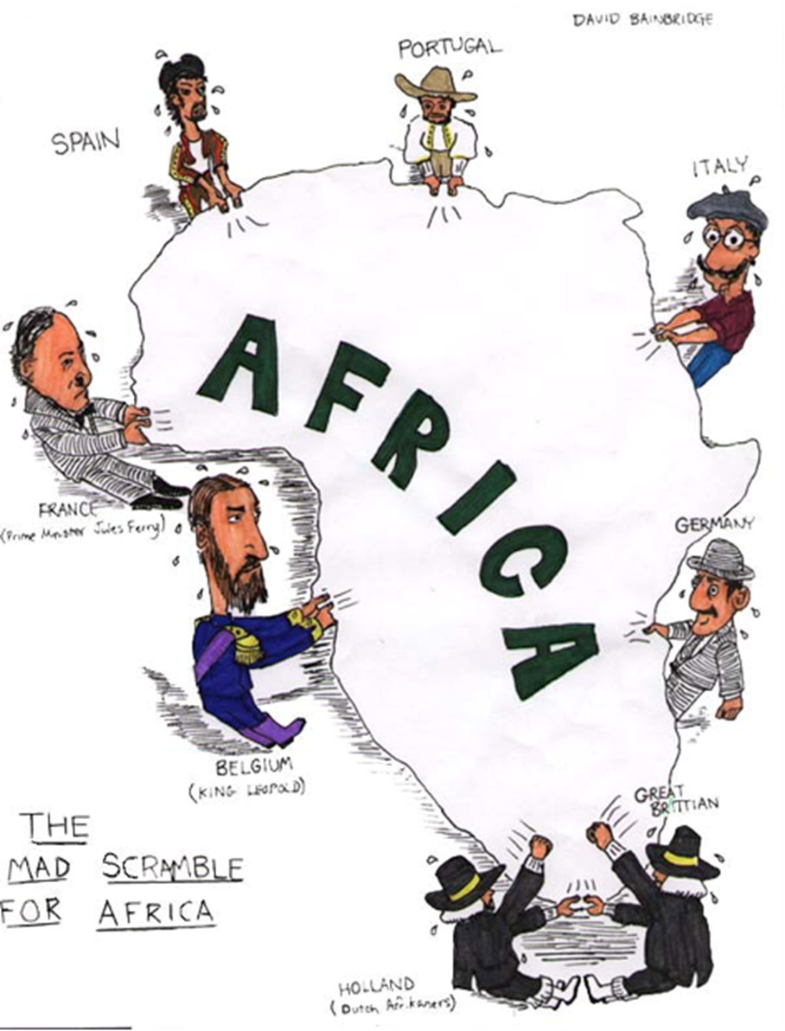
1. According to the cartoon what European countries were competing for parts of Africa?
2. How did the Berlin Conference lead to the situation shown in the cartoon?
3. Looking at the cartoon what emotions are being shown about the struggle to control Africa?
CARTOON 2

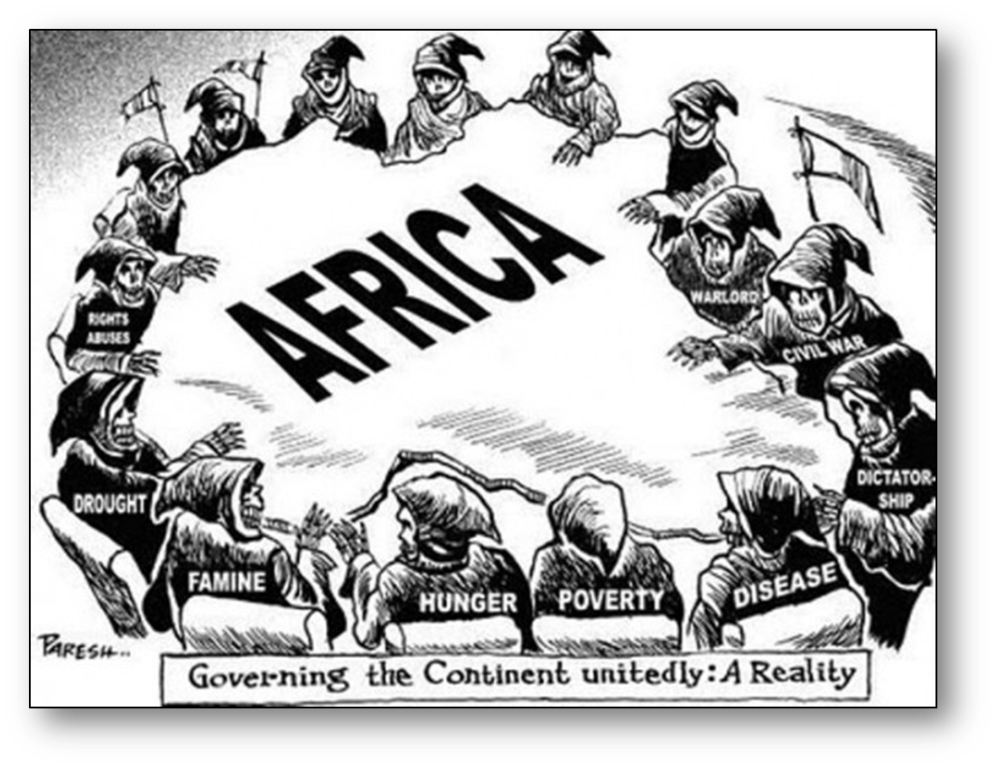
1. Describe the action taking place in this cartoon.
2. Explain the cartoon’s message.
3. What is the artist’s opinion of Imperialism? Why do you think that?
4. Examine the title (or caption) of the political cartoon: how does it relates to the situation it is depicting? What meaning does the title give to the illustration? Why might the author have chosen the words he did?

CARTOON 3
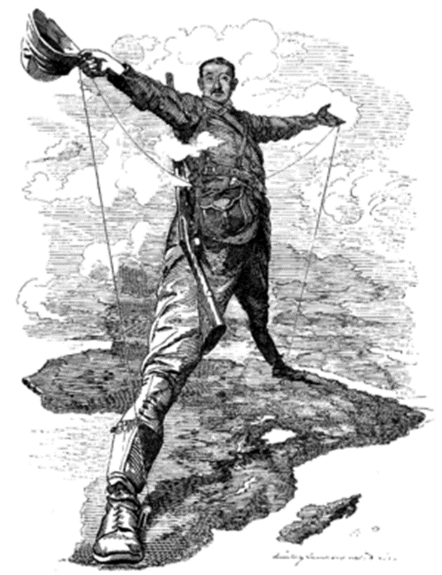
1. How is Cecil Rhodes dressed? What items is he carrying?
2. Based on the cartoon how do you think Rhodes viewed Africa? Why?
3. What things is Rhodes holding in his hands? What do you think this means?
4. What is Rhodes standing on? And can you make out what countries / areas he has his feet?
5. Create a title for this cartoon.

CARTOON 4
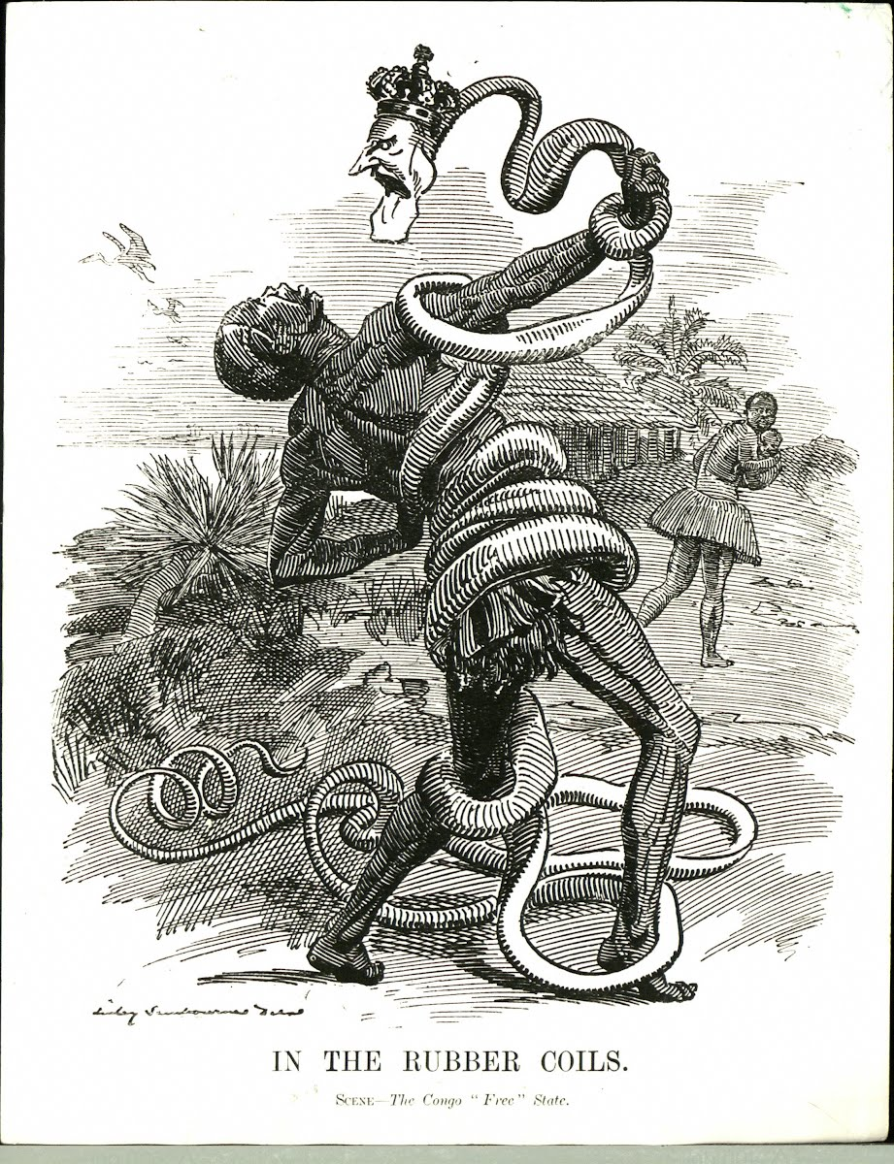
1. What is the man in the cartoon struggling against?
2. How does the woman in the background seem to feel?
3. Why did the artist depict the rubber vines as a snake with King Leopold as its head?
4. Whose “side” is the artist on, and how do you know?

CARTOON 5
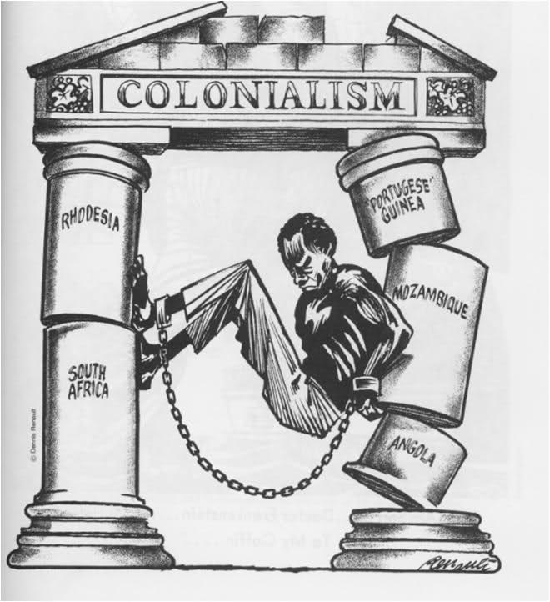
1. What is happening in the cartoon?
2. What European countries own the African countries represented?
3. How do you think the man in the cartoon feels?
4. What is the message of the cartoon?
5. Create a title for this political cartoon?

