Georgia Becomes A Royal Colony
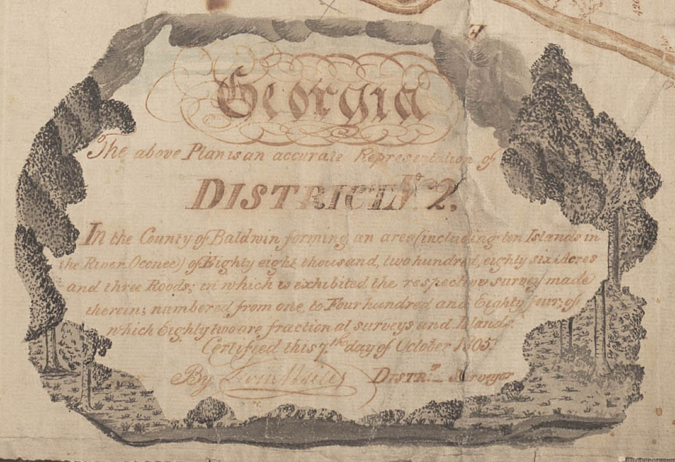
- What is a proprietary colony?

- What is a royal colony?

- Who was the first Royal Governor of GA?

- What type of legislature was set up?

- What is a parish?

- What were the upper and lower houses of the legislature called?

- What else did the first governor do in terms of government?

- What was the French and Indian War and who was involved in the war?

- Why did the rivalry intensify between the two countries?

- What causes war to erupt?

- What was the Treaty of Paris of 1763?

- What did the Proclamation of 1763 do?

- In what year did Georgia’s new government meet and what was the colony’s capital and largest city?

- Who was Governor Ellis?

- By 1759, how much had the population of Ga grown?

- Why was Ellis eventually replaced?

- Who was the third and final royal governor of GA?

- The final royal governor believed that Ga would continue to grow if what three things occurred?

- What are palisades?

- Who were the crackers?

- What is independence in the time of the colonies?

