Name:___________________________________________________ Date:________________________________________________________-
Map of Southwest Asia
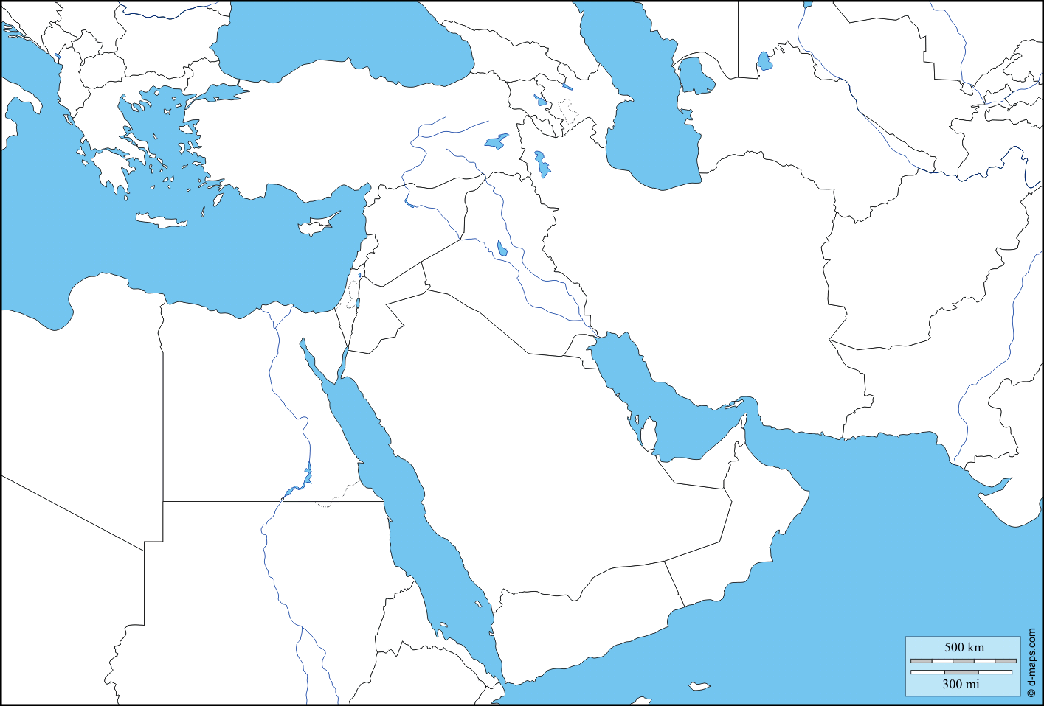
Suez Canal
Arabian Sea
Strait of Hormuz
Persian Gulf
Red Sea
Black Sea

Euphrates River
TURKEY

LEBANON SYRIA
Mediterranean Sea IRAQ Tigris River
West Bank IRAN AFGHANISTAN
ISRAEL JORDAN
Jordan River KUWAIT
SAUDI ARABIA
QATAR U.A.E

OMAN
YEMEN
Label each country and physical feature and color the map according to verbal directions form your teacher. (Countries are underlined)
Afghanistan United Arab Emirates (UAE) Qatar Yemen Mediterranean Sea Suez Canal Black Sea
Iran Saudi Arabia Kuwait Oman Tigris River Arabian Sea
Iraq Syria Turkey Jordan River Euphrates River Strait of Hormuz
Lebanon Israel Jordan Red Sea Persian Gulf West Bank

