NAME: ___________________________ Due Date: _____________
STUDY GUIDE for Government/Economics of Southwest Asia
Define the following terms:
- Autocracy: government in which one person has uncontrolled or unlimited authority over others
- Oligarchy: government by a small group of people
- Democracy: the supreme power is vested in the people and exercised by them directly or indirectly
- Theocracy: a government ruled by religious leaders who claim God’s authority
- Presidential democracy: a political system in which voters separately choose a leader to serve in the government as head of the executive branch
- Parliamentary democracy: a form of government in which voters elect representatives to a lawmaking body, which then chooses the leader; head of government is a part of the legislative branch
- Command economy: government decides what is produced, who receives goods and services, and how things are produced
Examples: North Korea and Cuba are close to pure command.
- Market economy: consumers and producers determine what’s produced, who receives goods/services, and how things are produced (supply and demand). Also called “capitalism” or “free market” – encourages entrepreneurs (creators of new businesses)
- Mixed economy: when a country combines elements of market and command systems (and sometimes traditional elements as well) *Most societies fall under this category, including ours!)
Part 2
- Israel:
  - Type of government: Parliamentary Democracy
  - Title and name of current leader: Prime Minister Benjamin Netanyahu
- Iran:
  - Type of government: Theocracy (Islamic Republic)
  - Title and name of current leader: Ayatollah Ali Khamenei and President Hasan Ruhani
- Saudi Arabia
  - Type of government: Absolute Monarchy
  - Title and name of current leader: King Salman
Part 3
- What does OPEC stand for and what does it do?
  - Organization of the Petroleum Exporting Countries – decides how much oil to produce and the price

Part 4
- Turkey’s primary industries: textiles, steel, and cars
- Israel’s primary industries: high-tech manufacturing (aviation, computer), financial services, timber, agriculture
- Saudi Arabia’s primary industries: world’s leading producer of oil
Draw and place Turkey, Israel, and Saudi Arabia on the economic continuum below:
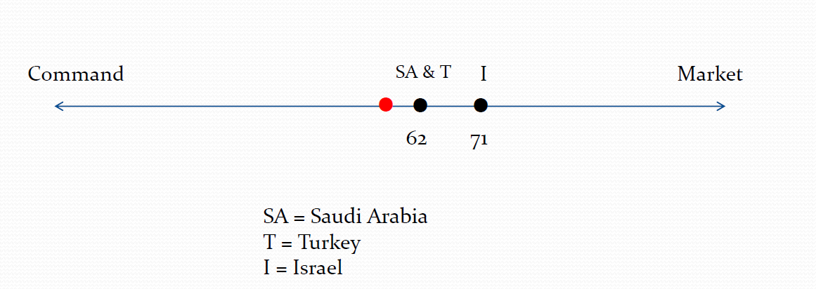

Part 5: Understand the meaning of diversification.
Definition of Diversification: an economy that depends on a variety of goods and services for income (instead of just one
What is its purpose? The purpose of diversification is to make a country’s economy sustainable (long-lasting).
Why do particular countries in the Middle East need to focus on it? Too many countries’ economies depend only on oil which is a non-renewable resource that will eventually run out.
How would it look in action? A country could diversify by having more than one industry, such as tourism, clothing, agriculture, and manufacturing.

