New South, WW1 & WW2 Study Guide
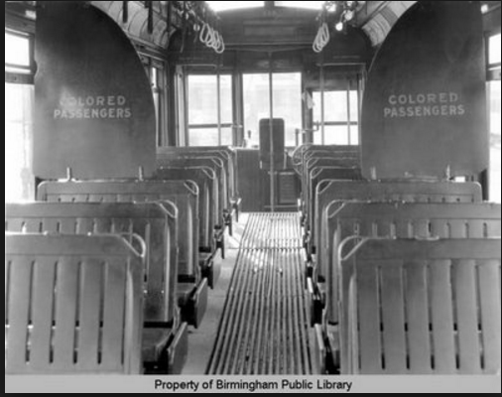
COLORED
PASSENGERS

P
1. Look at the picture above. Which court case ruling made this act legal?

2. Why was Henry Grady known as the “voice of The New South”?

3. What was the result of the passage of “Jim Crow” laws?

4. What was the main purpose of the International Cotton Exposition?

5. What Georgia leader based his early career on supporting the poor farmers, both black and white, on a platform of lower taxes for farmers?

6. Who replaced Tom Watson in Congress after he died while still serving his term?

7. The cause of the 1906 Race Riot in Atlanta was caused by

8. Who was accused of killing Mary Phagan at the pencil factory on April 26, 1913?

9. How did the county unit system affect voting and politics in Georgia in the early 1900’s?

10. How would the Bourbon Triumvirate describe the New South Period?

11. Whose rights did Tom Watson and the Populists fight for?

12. 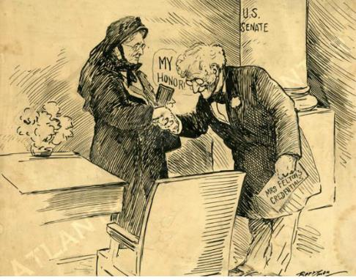
What is the subject of the political cartoon?

13. Preventing blacks from voting was called?

14. What Constitutional amendment was violated by Jim Crow legislation?

15. In 1920, the Nineteenth Amendment to the U.S. Constitution was ratified. How did this amendment change the make-up of those who could vote in Georgia?

16. What did Booker T. Washington was an outstanding civil rights leader and the president of the Tuskegee Institute, believe about social equality among blacks and whites of his day?

17. What did DuBois believe about social equality among blacks and whites of his day?

18. Who was selected as the first black president of both Morehouse and Atlanta University?

19. What organization did Lugenia Burns Hope establish?

20. What business made Alonzo Herndon a successful businessman?

21. What led to the decision for the United States to enter World War I?

22. World War I begins with ______________________________and ends with the signing of_________________________________.

23. Why was Georgia important to the World War 1 effort?

24. What caused cotton production to drop from 1.75 million bales in 1914 to 588,000 bales in 1923?

25. This insect caused cotton production to drop and on the hills of that GA suffered a server _______________ that made farmers pack up and move.

26. Which U.S. President believed in the practice of laissez-fair policies that helped bring about the depression in the 30s?
* * Borrowing more money than could be
repaid
* Speculating in the Stock Market
* Overproducing farm products
These events led to_______?
27.

28. What programs were a part of Roosevelt's "New Deal"?

29. Place the following events in the correct chronological order they occurred:
1. Sharp economic growth
2. Drought and Dust Bowl
3. Black Tuesday
4. World War I

30. Eugene Talmadge became governor of Georgia in 1933. He disliked relief efforts, public welfare and debts. As a result of these beliefs, Governor Talmadge

31. The Civilian Conservation Corps (CCC) was a popular New Deal program because it put unemployed people to work during the Depression. What was a result of the CCC?

32. What was the name of the federal assistance program designed to bring economic relief during the Great Depression?

33. Which president was responsible for creating the programs that would bring economic relief during the Great Depression?
34. What program loaned money to farmer's cooperatives to help them build power lines and purchase power wholesale?

35. What New Deal program restricted agricultural production by paying farmers to grow fewer crops?

36. The purpose of Social Security is to

37. What act encouraged Georgia’s farmers to stop relying solely on cotton, and to plant peanuts, corn, tobacco, and other crops?

38. What was a major difference between the New Deal and the policies followed by earlier administrations was that the New Deal

39. The United States did not become involved in World War II until December 7, 1941, which President Franklin Roosevelt called “a day that will live in infamy.” What caused the United States to get involved in World War II?

40. What describes the involvement of the United States in WWII before the bombing of Pearl harbor?

41. This term means to give into the demands of an aggressor in order to avoid war.

42. Why was Carl Vinson recognized by two United States presidents?

43. What was the name of the Marietta factory used to build B-29 bombers during WWII?

44. Richard B. Russell helped to bring 15 __________________________ to GA

45. During World War II, the Georgia cities of Savannah and Brunswick were best known for

46. In what way did Georgia contribute to the Allies during World War II?
1.

2.

3.

47. The systematic killing of 6 million Jewish people by the Nazis was known as the

48. President Franklin Delano Roosevelt’s Little White House was in Warm Springs, Georgia. Why did the president often travel to Georgia?

49. A ruler with total power over a country who has typically obtained power by force.
50. The national policy of abstaining (sitting out) from political or economic relations with other countries.

