Name:___________________________________________________ Date:________________________________________________________-
Physical Features Map of Southwest Asia
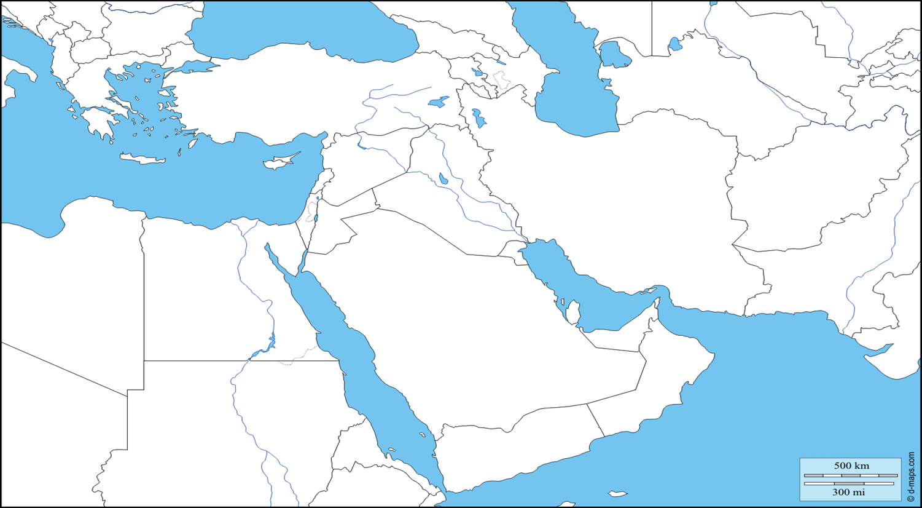
Label each physical feature of the map using your text book to help.
Suez Canal Arabian Sea Euphrates River
Tigris River Strait of Hormuz Persian Gulf
West Bank Jordan River
Gaza Strip Red Sea

