Name:___________________________________________________ Date:________________________________________________________-
Political Map of Southwest Asia
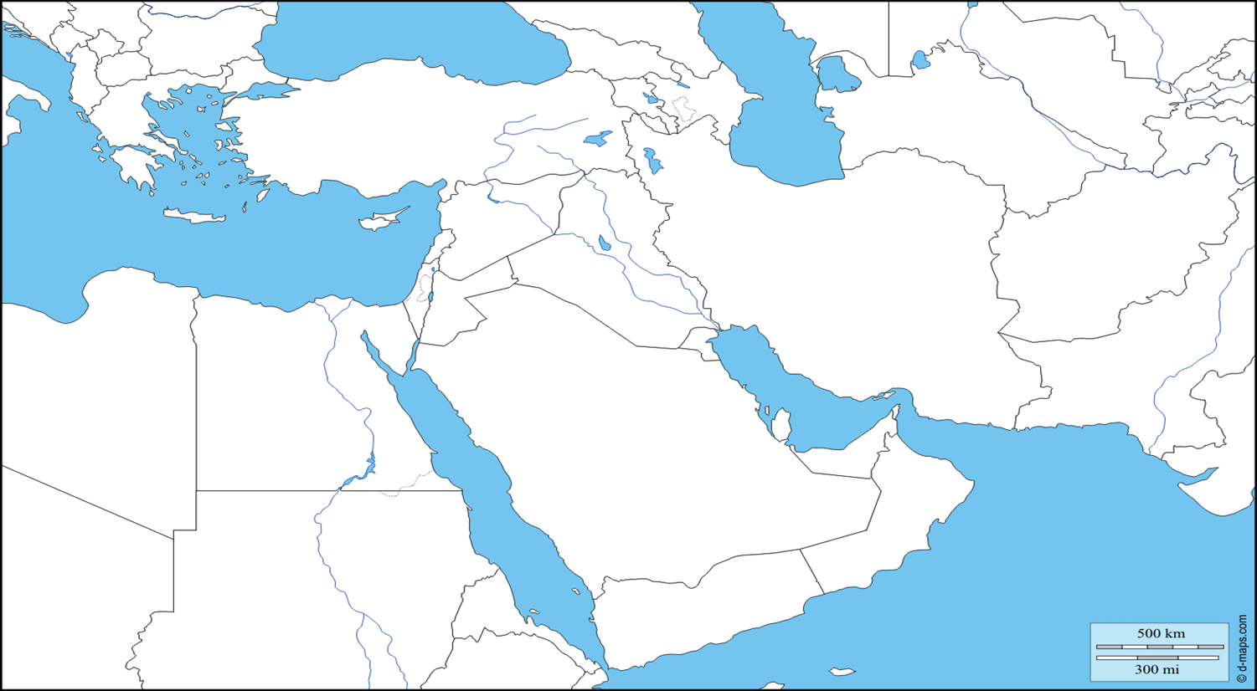
Label each country listed below on the map using your text book to help.
Afghanistan United Arab Emirates (UAE) Kuwait
Iran Saudi Arabia Turkey
Iraq Syria
Qatar Israel

