Name: __________________________
Date: __________ Period: __________

Unit 3: Georgia Colonization
I. Georgia as a Trustee Colony
- ____________________ Name of the first settlement (city) in Georgia

- ____________________ Signed the Charter of 1732 which created GA

- ____________________ “Father of Georgia”; Founder and Head Trustee of Georgia

- ____________________ Number of Trustees that lead GA during the Trustee Period

- ____________________ Served as interpreter for Oglethorpe and Tomochichi

- ____________________ Yamacraw Chief that assisted Oglethorpe and the GA colonists

- ____________________ First city built by the Salzburgers in Georgia

- ____________________ Dissatisfied Georgia colonists; Most came from Scotland

- ____________________ People unable to pay their bills; imprisoned in Great Britain

- ____________________ What was the policy on land inheritance?

- ____________________ What kind of colony was Georgia when first formed?

- ____________________ Religion that was not allowed to settle (live in) Georgia

- ____________________ What were the Trustees prohibited from doing in the new ____________________ colony? ____________________
- ____________________ What were the families sent to Georgia on charity given? ____________________ ____________________
- ____________________ What did these colonists promise to do in return for what the
Trustees gave them?

- ____________________ Why did the Trustees return the charter to the King? When did ____________________this happen?

- ____________________ What were Georgia’s original boundaries as stated in the ____________________ Charter of 1732? ____________________
____________________

- ____________________ Name three (3) reasons for the founding of Georgia
____________________
____________________
- ____________________ Who won the War of Jenkins Ear?

- ____________________ Why did the Spanish leave FL for good?

- ____________________ What two groups opposed slavery in the colony?

II. Georgia as a Royal Colony
- ____________________ Type of colony GA became after the Charter of 1732 expired

- ____________________ Title of the person who controlled (governed) Royal Colonies

- ____________________ Name the three (3) Royal Governors of Georgia
____________________
____________________

- ____________________ Economic system where you export more than you import

- ____________________ Three rules/laws the Trustees enforced for Georgia; that
____________________ changed during Georgia’s time as a Royal Colony
____________________
- ____________________ What were the colonists expected to supply England with?
____________________
____________________
- ____________________ Who was John Martin Bolzius?

- _________________ What was the religion of the Salzburgers and why did they come to _________________ Georgia?

- __________________ Why was the first location of Ebenezer not a good choice?

- __________________ What initially kept the Salzburgers separate from other Georgians?

- ___________________ Who was Samuel Nunes?

- ____________________ Person, considered property, forced to work for their owner

- ____________________ Person, working for their owner to pay off a debt

III. The Life of People in Colonial Georgia and America

- __________________ What are the 13 English Colonies? Be able to locate on a map
___________________ _______________ ________________ _____________
____________________ ________________ ________________ _____________
____________________ ________________ ________________ ______________
- 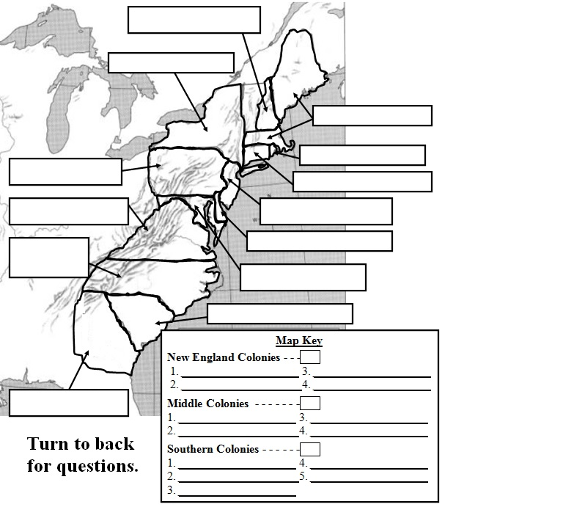

- ____________________ Type of education in the New England, Middle Atlantic and ____________________ Southern colonies.
____________________

- ____________________ Type of religion in the New England, Middle Atlantic and ____________________ Southern colonies.
____________________

- ____________________ Type of economy in the New England, Middle Atlantic and ____________________Southern colonies.
____________________

- ____________________ Type of social life in the New England, Middle Atlantic and
____________________ Southern colonies.
____________________

