Name: ____________________
Date: _____________________

Unit 4: American Revolution and Statehood, “Almost There”
I. Causes of the American Revolution

- _________________________ Conflict between France and Great Britain where both sides allied with several Native American Tribes

2. _________________________ Law that placed taxes on all paper goods and products

- _________________________ Document, created by King George III, that awarded all land west of the Appalachian Mountains to Native Americans; angered Georgia colonists

- _________________________ Set of four laws created to punish the Massachusetts colony for the Boston Tea Party

- _________________________ Document that stated the colonies were free of British control

- _________________________ Three Georgia signers of the Declaration of Independence
_________________________
_________________________

II. The American Revolution

- _________________________ Female Georgia patriot who captured and killed a group of Tories (Georgians loyal to Britain) during the Revolution.

- _________________________ African American soldier wounded in the Battle of Kettle Creek;
responsible for saving Elijah Clarke’s life

- _________________________ Led Georgia’s militia to victory over 800 British soldiers

- _________________________ Colonists who favored the colonies gaining independence from the British

- _________________________ Colonists who favored remaining under British control

- _________________________ American Revolution battle in GA; victory for Georgia as the militia were able to defeat and gain supplies from the British

- _________________________ American Revolution battle in GA; loss for Georgia as the militia and continental army failed to retake GA’s capital city from British control

III. Governing Documents

- _________________________ Georgia’s first constitution; document adopted in Savannah that created Georgia’s first unicameral government

- _________________________ First United States (federal) constitution; created a weak central government and was eventually replaced by our current constitution
- _________________________ Two representatives from GA that helped to write the new constitution at _________________________ the Constitutional Convention of 1787
- What does it mean to be a Royal Colony?
18. Name the three Royal Governors of Georgia in the order they served.
1._______________________________
2._______________________________
3._______________________________
- Which of the Royal Governors made the most contributions in the area of defense of the colony?

- What did Georgia gain from the French and Indian War?

- The Treaty of Paris of 1763 ending the French and Indian War involved what countries?

- How did the French and Indian War lead to America’s Revolutionary War?

- How did the French and Indian War effect Georgia’s growth and development?

- What did the Townshend Acts of 1767 levy (impose) a tax on?

- Why was anti-British sentiment less in Georgia than in the other colonies during the Revolutionary period?

- Who was the main writer of the Declaration of Independence?

- Under Georgia’s first constitution who selected the governors?

- What were the 4 provisions of the “Intolerable” Acts?

- Where did the first colonial victory in Georgia during the American Revolution occur? Why was this battle so important to GA?

- *You will have some questions on interpreting this political cartoon and these maps…be familiar with these!
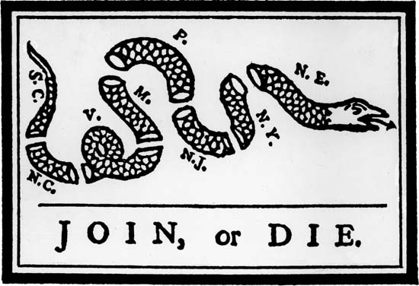
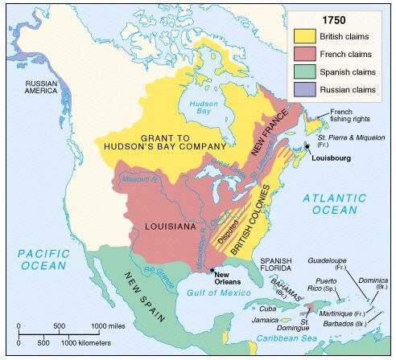
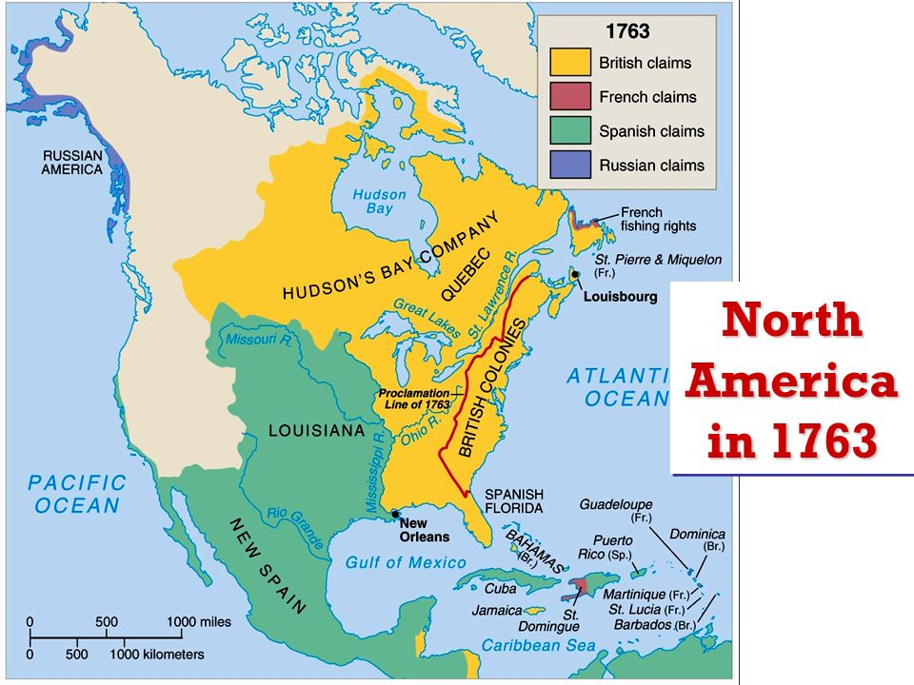
- *You will also have a section where we give you a quote and you have to decide if it is most likely a Patriot quote or a Tory quote…make sure you know the difference between these two groups!

- Why did Britain tax goods in the colonies?

- Put the following events in their order of occurrence. (French and Indian War, Declaration of Independence, Intolerable Acts, Stamp Act)
1.______________________________________________________________________
2.______________________________________________________________________
3.______________________________________________________________________
4.______________________________________________________________________
5.______________________________________________________________________
34. What goods were taxed under the Stamp Act?

35. Why was Georgia reluctant to join the revolution?

36. Who controlled Georgia during the revolution?

37. What was the name of the Georgia royal governor that was a loyalist?

38. Why did the patriots want independence from British rule?

