Name: ____________________
Date: _____________________

Unit 4: American Revolution and Statehood, “Almost There”
I. Causes of the American Revolution

- French and Indian War Conflict between France and Great Britain where both sides allied with several Native American Tribes

2. Stamp Act Law that placed taxes on all paper goods and products

- Proclamation of 1763 Document, created by King George III, that awarded all land west of the Appalachian Mountains to Native Americans; angered Georgia colonists

- Intolerable Acts Set of four laws created to punish the Massachusetts colony for the Boston Tea Party

- Declaration of Independence Document that stated the colonies were free of British control

- Button Gwinnett Three Georgia signers of the Declaration of Independence
Lyman Hall
George Walton

II. The American Revolution

- Nancy Hart Female Georgia patriot who captured and killed a group of Tories (Georgians loyal to Britain) during the Revolution.

- Austin Dabney African American soldier wounded in the Battle of Kettle Creek;
responsible for saving Elijah Clarke’s life

- Elijah Clarke Led Georgia’s militia to victory over 800 British soldiers

- Patriots/Whigs Colonists who favored the colonies gaining independence from the British

- Loyalists/Tories Colonists who favored remaining under British control

- Battle of Kettle Creek American Revolution battle in GA; victory for Georgia as the militia were able to defeat and gain supplies from the British

- Siege of Savannah American Revolution battle in GA; loss for Georgia as the militia and continental army failed to retake GA’s capital city from British control

III. Governing Documents

- Constitution of 1777 Georgia’s first constitution; document adopted in Savannah that created Georgia’s first unicameral government

- Articles of Confederation First United States (federal) constitution; created a weak central government and was eventually replaced by our current constitution
- Abraham Baldwin Two representatives from GA that helped to write the new constitution at William Few the Constitutional Convention of 1787

- What does it mean to be a Royal Colony? A colony ruled directly by the king.
18. Name the three Royal Governors of Georgia in the order they served.
1. John Reynolds
2. Henery Ellis
3. James Wright
- Which of the Royal Governors made the most contributions in the area of defense of the colony?
James Wright
- What did Georgia gain from the French and Indian War?
An extension of their southern boundary to the St. Mary’s River
- The Treaty of Paris of 1763 ending the French and Indian War involved what countries?
Spain, France, and Great Britain
- How did the French and Indian War lead to America’s Revolutionary War?
High debt that lead to taxing the colonies without representation which caused conflict
- How did the French and Indian War effect Georgia’s growth and development?
By extending the boundaries it allowed for more settlers which increased their economy
- What did the Townshend Acts of 1767 levy (impose) a tax on?
Placed an import tax on glass, paint, oil, lead, paper, and tea
- Why was anti-British sentiment less in Georgia than in the other colonies during the Revolutionary period?
Georgia was a far younger colony and still have family in GB they got financial support from Great Britain
- Who was the main writer of the Declaration of Independence?
Thomas Jefferson
- Under Georgia’s first constitution who selected the governors?
The legislature

- What were the 4 provisions of the “Intolerable” Acts?
- Closed the port of Boston until they payed for the destroyed tea
- Ended to the constitution of Massachusetts - only one town meeting was permitted a year in Massachusetts, unless approved by the governor.
- Gave the power for all trials in the colony to be sent to Great Britain and heard under a British judge
- Compelled the colonists to feed and shelter the soldiers employed to punish them(Quartering Act)
- Where did the first colonial victory in Georgia during the American Revolution occur? Why was this battle so important to GA?
It happened at The Battle of Kettle near Washington, GA it is important because it helped boost the morale of the GA militia and they gained much needed supplies.
- *You will have some questions on interpreting this political cartoon and these maps…be familiar with these!
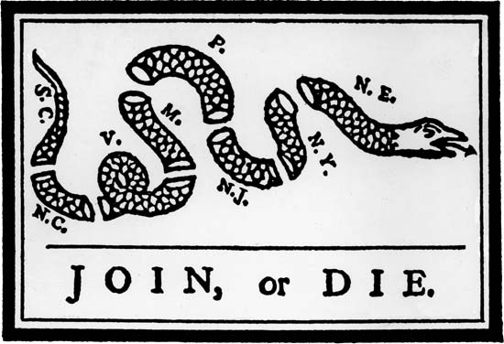
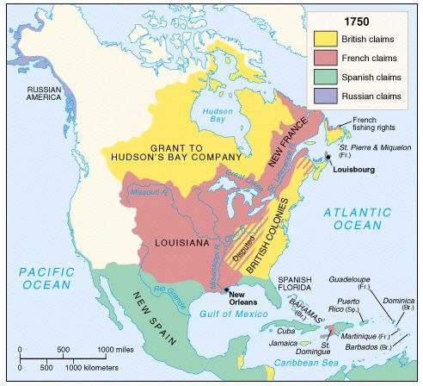
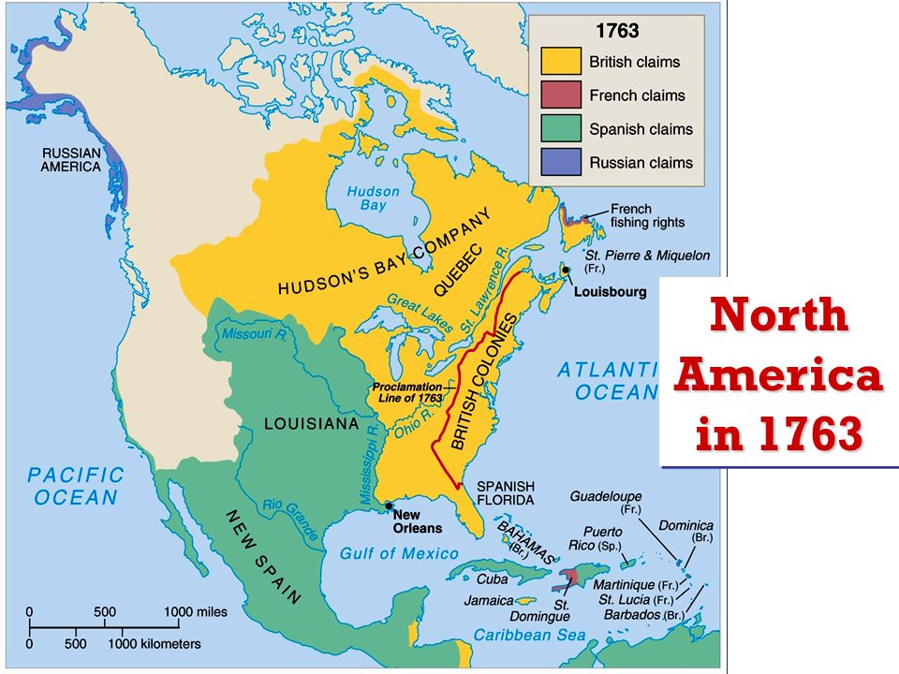
- *You will also have a section where we give you a quote and you have to decide if it is most likely a Patriot quote or a Tory quote…make sure you know the difference between these two groups!

- Why did Britain tax goods in the colonies?

To pay off the debt incurred from the French and Indian War
- Put the following events in their order of occurrence. (French and Indian War, Declaration of Independence, Intolerable Acts, Stamp Act)
1. French and Indian War
2. Stamp Act
3. Intolerable Acts
4. Declaration of Independence
34. What goods were taxed under the Stamp Act?
It required them to pay a tax on every piece of printed paper they used. Ship's papers, legal documents, licenses, newspapers, other publications, and even playing cards were taxed.
35. Why was Georgia reluctant to join the revolution?
Georgia was the youngest colony and they still had family in GB they got financial support from Great Britain and a lot of them were still 1st generation colonist.

36. Who controlled Georgia during the revolution?
Great Britain
37. What was the name of the Georgia royal governor that was a loyalist?
James Wright
38. Why did the patriots want independence from British rule?
Because they felt that the king was a tyrant and that he did not care about the colonist and that they should have the right to governor themselves.

