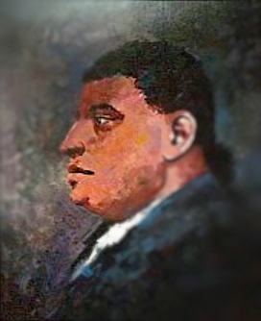
Name at birth: Paul Slocum
Paul Cuffe was a Massachusetts shipping magnate of the early 19th century — and probably the wealthiest African American of his era. He was the youngest of the ten children of emancipated African Kofi Slocum and Wampanoag tribe member Ruth Moses. Paul was raised in Westport and educated by abolitionist Quakers, and at the age of 14 began the life of a sailor. Three years later, he was jailed for three months by the British during the American Revolution, and three years after that he began his own shipping business between Westport and Nantucket (1779). The next year he was briefly jailed again — for civil disobedience: Cuffe argued that he shouldn’t be taxed, as he was not allowed to vote. Although he lost his case, his action led to a change in the law by 1783.
In the last two decades of the 19th century, Cuffe became a wealthy and respectable Atlantic merchant, trading in the Caribbean, Europe and Russia. All this was at a time when the trade in African slaves was still booming; Cuffe and his all-black crew risked kidnapping and captivity as they sailed the hemisphere. Much of Cuffe’s success came from his associations with Quakers, from whom he learned of abolitionism and the efforts to re-settle emancipated slaves in Africa. Cuffe voyaged to Sierra Leone to investigate the possibilities of emigration in 1810, and again in 1815, when he paid passage for 18 adults and 20 children. His early back-to-Africa venture failed and he died two years later, but he left behind a substantial estate and a reputation for philanthropy as well as business acumen. As a young man, Paul Cuffe changed his surname from Slocum — the name of his father’s one-time master — to Cuffe (sometimes seen as Cuffee), presumably a variation on his father’s first name (Kofi)
Facts about Paul Cuffe
Died at 58 years old
Born: January 17, 1759
Died: September 9, 1817
Birthplace: Cuttyhunk Island, Massachusetts, United States
Best known as: The richest African American of the early 18th century

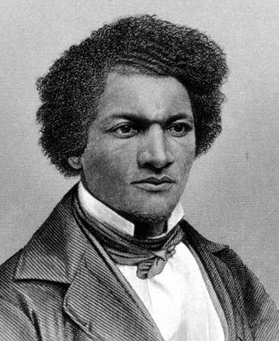
Denmark Vesey was executed on 2 July 1822 after being accused of planning a slave rebellion against slave owners and other whites in Charleston, South Carolina.
Denmark Vesey was a well-respected carpenter and minister who in his teens had been sold into slavery from the West Indies island of St. Thomas. For years he was the household servant to Captain Joseph Vesey, who settled in Charleston in 1783. Vesey won $1,500 in a lottery in the year 1800. He used the money to buy his freedom and set up a carpentry shop, where he prospered. Educated and financially successful, he also co-founded a separate black Methodist church in Charleston in 1816 (though it was closed by white authorities four years later).
In 1822, Vesey was accused of being the leader of a secret plot to rebel against whites, a plot that supposedly involved 9,000 slaves and more than two years of preparation. The alleged plan was for the slaves to murder as many whites as they could, then set sail for Africa or Haiti. In the wake of rumors of the plot, Charleston authorities charged 131 people with conspiracy, convicted 67 and executed at least 35, including Denmark Vesey. Vesey was no longer a slave at the time he planned the revolt—he had purchased his own freedom several years before, so his motives were not self-serving. Thomas Wentworth Higginson "the most elaborate insurrectionary project ever formed by American slaves.... In boldness of conception and thoroughness of organization there has been nothing to compare it with."Denmark Vesey’s birthplace and birthdate are uncertain, as are most of the details of his life before he was sold to Joseph Vesey in 1781.
Facts about Denmark Vesey
Born: c. 1767
Died: July 2, 1822 (execution by hanging)
Birthplace: ?
Best known as: Leader of South Carolina's 1822 slave rebellion plot

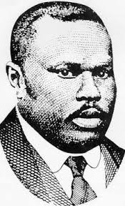
Marcus Garvey was a proponent of the Black Nationalism and Pan-Africanism movements, inspiring the Nation of Islam and the Rastafarian movement. Through his public speeches and his newspaper Negro World, Marcus Garvey became one of the most influential black leaders of the early 20th century. Born and raised in Jamaica, Garvey travelled in Central and South America, then moved to England to continue his education. In 1914 he started the Universal Negro Improvement Association and began speaking out publicly in favor of worldwide black unity and an end to colonialism. He moved to the United States in 1916. By 1919, Marcus Garvey and U.N.I.A. had launched the Black Star Line, a shipping company that would establish trade and commerce between Africans in America, the Caribbean, South and Central America, Canada and Africa.
It was both a business venture and a part of his “back to Africa” plan for Americans of African descent — the notion that African-Americans should return to Africa and set up their own new country there. Garvey was always a controversial figure: he favored fiery rhetoric and elaborate uniforms, and was considered a dangerous character by some established politicians. F.B.I. Director J. Edgar Hoover's fixated on ruining Garvey for his radical ideas. Hoover felt threatened by the black leader, fearing he was inciting blacks across the country to stand up in militant defiance. Hoover referred to Garvey as a "notorious negro agitator" and for several years, desperately sought ways to find damning personal information on him, even going so far as to hire the first black F.B.I. agent in 1919 in order to infiltrate Garvey's ranks and spy on him. Marcus Garvey was jailed in 1925 after being convicted of mail fraud (related to the sale of stock in the Black Star line), but his sentence was reduced and he was deported to Jamaica two years later. Marcus Garvey died in London in 1940 after several strokes. Due to travel restrictions during World War II, his body was interred in London. In 1964, his remains were exhumed and taken to Jamaica, where the government proclaimed him Jamaica's first national hero and re-interred him at a shrine in the National Heroes Park. But his memory and influence remain. His message of pride and dignity inspired many in the early days of the Civil Rights movement in the 1950s and 1960s.
Facts about Marcus Garvey
Marcus Garvey died at 52 years old
Born: August 17, 1887
Died: June 10, 1940 (cerebral hemorrhage)
Birthplace: St. Ann's Bay, Jamaica
Best known as: Founder of the "back to Africa" movement

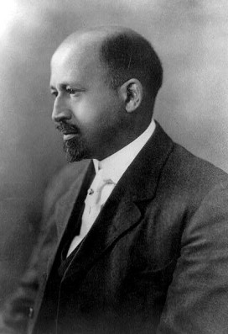
Name at birth: William Edward Burghardt DuBois
W.E.B. Du Bois was one of the most important African-American activists during the first half of the 20th century.
Du Bois was a scholar and political activist who helped found the National Association for the Advancement of Colored People (NAACP) and supported Pan-Africanism. DuBois attended Harvard University and in 1895 became the first African-American to receive a doctorate from the school. He became a university professor, a prolific writer and a pioneering social scientist on the topic of black culture.
W.E.B. DuBois particularly disagreed with black leaders such as Booker T. Washington who urged integration into white society; Du Bois championed global African unity and (especially in later years) separatism. He distilled his views in his famous 1903 book The Souls of Black Folk.
In 1909 he was a founding member of the NAACP, an organization promoting progress and social equality for blacks. Du Bois continued for decades as a strong public voice on behalf of African-Americans. Not long after, Du Bois published his landmark study—the first case study of an African-American community—The Philadelphia Negro: A Social Study (1899), marking the beginning of his expansive writing career. In the study, he coined the phrase "the talented tenth," a term that described the likelihood of one in 10 black men becoming leaders of their race.
While working as a professor at Atlanta University, W.E.B. Du Bois rose to national prominence when he very publicly opposed Booker T. Washington's "Atlanta Compromise," an agreement that asserted that vocational education for blacks was more valuable to them than social advantages like higher education or political office. Du Bois criticized Washington for not demanding equality for African Americans, as granted by the 14th Amendment. Du Bois fought what he believed was an inferior strategy, subsequently becoming a spokesperson for full and equal rights in every realm of a person's life.
W.E.B. Du Bois died on August 27, 1963—one day before Martin Luther King Jr. delivered his "I Have a Dream" speech at the March on Washington—at the age of 95, in Accra, Ghana, while working on an encyclopedia of the African Diaspora.
Facts about W. Bois
W. E. B. Du Bois died at 95 years old
Born: February 23, 1868 Died: August 27, 1963
Birthplace: Great Barrington, Massachusetts, United States
Best known as: Opposing the idea of biological white superiority
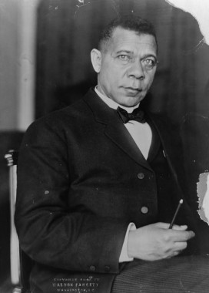
Booker T. Washington was an educator and one of the foremost African-American leaders of the late 19th and early 20th centuries, founding the Tuskegee Normal and Industrial Institute, now known as Tuskegee University.
Born into slavery in Virginia in the mid-to-late 1850s, Booker T. Washington put himself through school and became a teacher after the Civil War. In 1881, he founded the Tuskegee Normal and Industrial Institute in Alabama (now known as Tuskegee University), which grew immensely and focused on training African Americans in agricultural pursuits. A political adviser and writer, Washington clashed with intellectual W.E.B. Du Bois over the best avenues for racial uplift.
In 1872, Booker T. Washington left home and walked 500 miles to Hampton Normal Agricultural Institute in Virginia. Along the way he took odd jobs to support himself. He convinced administrators to let him attend the school and took a job as a janitor to help pay his tuition.
The school's founder and headmaster, General Samuel C. Armstrong, soon discovered the hardworking boy and offered him a scholarship, sponsored by a white man. Armstrong had been a commander of a Union African-American regiment during the Civil War and was a strong supporter of providing newly freed slaves with a practical education. Armstrong became Washington's mentor, strengthening his values of hard work and strong moral character. In 1895, Booker T. Washington publicly put forth his philosophy on race relations in a speech at the Cotton States and International Exposition in Atlanta, Georgia, known as the "Atlanta Compromise." In his speech, Washington stated that African Americans should accept disenfranchisement and social segregation as long as whites allow them economic progress, educational opportunity and justice in the courts. This started a firestorm in parts of the African-American community, especially in the North. Activists like W.E.B. Du Bois (who was working as a professor at Atlanta University at the time) deplored Washington's conciliatory philosophy and his belief that African Americans were only suited to vocational training. Du Bois criticized Washington for not demanding equality for African Americans, as granted by the 14th Amendment, and subsequently became an advocate for full and equal rights in every realm of a person's life. Though Washington had done much to help advance many African Americans, there was some truth in the criticism. During Washington's rise as a national spokesperson for African Americans, they were systematically excluded from the vote and political participation through black codes and Jim Crow laws as rigid patterns of segregation and discrimination became institutionalized throughout the South and much of the country. Booker T. Washington remained the head of Tuskegee Institute until his death on November 14, 1915, at the age of 59, of congestive heart failure.

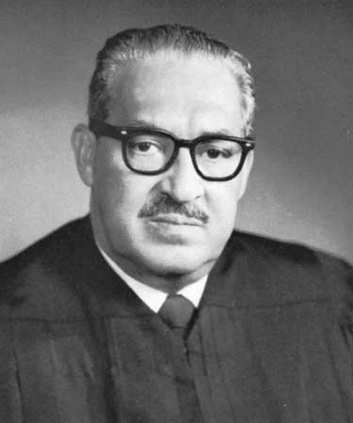
Attorney Thurgood Marshall led the civil rights case of Brown v. Board of Education of Topeka to a successful hearing at the Supreme Court of the United States in 1954. He became the court’s first African-American justice 13 years later. The descendant of slaves, Thurgood Marshall graduated from all-black Lincoln University in Pennsylvania in 1930, then received a law degree from Howard University in 1933. He opened his own law practice in Baltimore and became known as a lawyer who would speak up for the rights of African-Americans; this led him to a job with the National Association for the Advancement of Colored People (NAACP) in 1936. He spent more than two decades with the NAACP, gaining his greatest fame for the case of Brown v. Board of Education from 1952-54. When the Supreme Court ruled in 1954 that “Separate educational facilities are inherently unequal,” Marshall and the NAACP won a great victory for civil rights.
In 1930, he applied to the University of Maryland Law School, but was denied admission because he was Black. This was an event that was to haunt him and direct his future professional life. Thurgood sought admission and was accepted at the Howard University Law School that same year and came under the immediate influence of the dynamic new dean, Charles Hamilton Houston, who instilled in all of his students the desire to apply the tenets of the Constitution to all Americans. Paramount in Houston's outlook was the need to overturn the 1898 Supreme Court ruling, Plessy v. Ferguson which established the legal doctrine called, "separate but equal." Marshall's first major court case came in 1933 when he successfully sued the University of Maryland to admit a young African American Amherst University graduate named Donald Gaines Murray.
After amassing an impressive record of Supreme Court challenges to state-sponsored discrimination, including the landmark Brown v. Board decision in 1954, President John F. Kennedy appointed Thurgood Marshall to the U.S. Court of Appeals for the Second Circuit. In this capacity, he wrote over 150 decisions including support for the rights of immigrants, limiting government intrusion in cases involving illegal search and seizure, double jeopardy, and right to privacy issues. Biographers Michael Davis and Hunter Clark note that, "none of his (Marshall's) 98 majority decisions was ever reversed by the Supreme Court." In 1965 President Lyndon Johnson appointed Judge Marshall to the office of U.S. Solicitor General. Before his subsequent nomination to the United States Supreme Court in 1967, Thurgood Marshall won 14 of the 19 cases he argued before the Supreme Court on behalf of the government. Indeed, Thurgood Marshall represented and won more cases before the United States Supreme Court than any other American. Justice Marshall died on January 24, 1993.

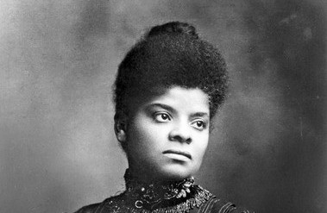
Ida B. Wells was an African-American journalist and activist who led an anti-lynching crusade in the United States in the 1890s.
A daughter of slaves, Ida B. Wells was born in Holly Springs, Mississippi, on July 16, 1862. A journalist, Wells led an anti-lynching crusade in the United States in the 1890s, and went on to found and become integral in groups striving for African-American justice.
On one fateful train ride from Memphis to Nashville, in May 1884, Wells reached a personal turning point. Having bought a first-class train ticket to Nashville, she was outraged when the train crew ordered her to move to the car for African Americans, and refused on principle.
As she was forcibly removed from the train, she bit one of the men on the hand. Wells sued the railroad, winning a $500 settlement in a circuit court case. However, the decision was later overturned by the Tennessee Supreme Court.
This injustice led Ida B. Wells to pick up a pen to write about issues of race and politics in the South. Using the moniker "Iola," a number of her articles were published in black newspapers and periodicals. Wells eventually became an owner of the Memphis Free Speech and Headlight, and, later, of the Free Speech.
Staying in the North, Wells wrote an in-depth report on lynching in America for the New York Age, an African-American newspaper run by former slave T. Thomas Fortune. She lectured abroad in 1893, looking to drum up support for her cause among reform-minded whites. Upset by the ban on African-American exhibitors at the 1893 World's Columbian Exposition, Wells penned and circulated a pamphlet entitled "The Reason Why the Colored American Is Represented in the World's Columbian Exposition." This effort was funded and supported by famed abolitionist and freed slave Frederick Douglass, and lawyer and editor Ferdinand Barnett. Also in 1893, Wells published A Red Record, a personal examination of lynchings in America.
In 1898, Wells brought her anti-lynching campaign to the White House, leading a protest in Washington, D.C., and calling for President William McKinley to make reforms. Ida B. Wells established several civil rights organizations. In 1896, she formed the National Association of Colored Women.
Working on behalf of all women, Wells, as part of her work with the National Equal Rights League, called for President Woodrow Wilson to put an end to discriminatory hiring practices for government jobs. She created the first African-American kindergarten in her community and fought for women's suffrage. In 1930, Wells made an unsuccessful bid for the state senate. Health problems plagued her the following year.
Ida B. Wells died of kidney disease on March 25, 1931, at the age of 68, in Chicago, Illinois. She left behind an impressive legacy of social and political heroism. With her writings, speeches and protests, Wells fought against prejudice, no matter what potential dangers she faced.

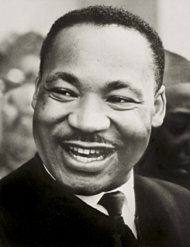
Martin Luther King Jr. was a Baptist minister and social activist, who led the Civil Rights Movement in the United States from the mid-1950s until his death by assassination in 1968.
Martin Luther King Jr. was born on January 15, 1929, in Atlanta, Georgia. King, a Baptist minister and civil-rights activist, had a seismic impact on race relations in the United States, beginning in the mid-1950s. Among his many efforts, King headed the Southern Christian Leadership Conference. Through his activism and inspirational speeches he played a pivotal role in ending the legal segregation of African-American citizens in the United States, as well as the creation of the Civil Rights Act of 1964 and the Voting Rights Act of 1965. King received the Nobel Peace Prize in 1964, among several other honors.
During his last year in seminary, Martin Luther King Jr. came under the guidance of Morehouse College President Benjamin E. Mays who influenced King’s spiritual development. Mays was an outspoken advocate for racial equality and encouraged King to view Christianity as a potential force for social change. After being accepted at several colleges for his doctoral study, including Yale and Edinburgh in Scotland, King enrolled in Boston University. During the work on this doctorate, Martin Luther King Jr. met Coretta Scott, an aspiring singer and musician, at the New England Conservatory School in Boston. They were married in June 1953 and had four children, Yolanda, Martin Luther King III, Dexter Scott and Bernice.
In the spring of 1963, Martin Luther King Jr. organized a demonstration in downtown Birmingham, Alabama. By the end of the Birmingham campaign, Martin Luther King Jr. and his supporters were making plans for a massive demonstration on the nation's capital composed of multiple organizations, all asking for peaceful change. On August 28, 1963, the historic March on Washington drew more than 200,000 people in the shadow of the Lincoln Memorial. It was here that King made his famous "I Have a Dream" speech, emphasizing his belief that someday all men could be brothers.
The rising tide of civil rights agitation produced a strong effect on public opinion. Many people in cities not experiencing racial tension began to question the nation's Jim Crow laws and the near century second class treatment of African-American citizens. This resulted in the passage of the Civil Rights Act of 1964 authorizing the federal government to enforce desegregation of public accommodations and outlawing discrimination in publicly owned facilities. This also led to Martin Luther King receiving the Nobel Peace Prize for 1964.
On March 9, 1965, a procession of 2,500 marchers, both black and white, set out once again to cross the Pettus Bridge and confronted barricades and state troopers. Instead of forcing a confrontation, King led his followers to kneel in prayer and they then turned back. The event caused King the loss of support among some younger African-American leaders, but it nonetheless aroused support for the passage of the Voting Rights Act of 1965. He was assassinated on April 4, 1968, and continues to be remembered as one of the most influential and inspirational African-American leaders in history.
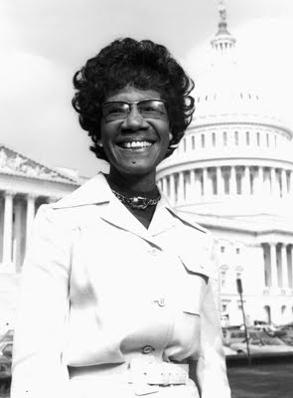

Shirley Chisholm Biography
U.S. Representative (1924–2005)
“My greatest political asset, which professional politicians fear, is my mouth, out of which come all kinds of things one shouldn’t always discuss for reasons of political expediency.”
—Shirley Chisholm

Synopsis
Born in Brooklyn, New York, in 1924, Shirley Chisholm is best known for becoming the first black congresswoman (1968), representing New York State in the U.S. House of Representatives for seven terms. She went on to run for the 1972 Democratic nomination for the presidency—becoming the first major-party African-American candidate to do so. Throughout her political career, Chisholm fought for education opportunities and social justice. Chisholm left Congress in 1983 to teach. She died in Florida in 2005.

Early Life and Career
Famed U.S. congresswoman and lifelong social activist Shirley Chisholm was born Shirley St. Hill on November 30, 1924, in a predominantly black neighborhood in Brooklyn, New York. Chisholm spent part of her childhood in Barbados with her grandmother. After graduating from Brooklyn College in 1946, she began her career as a teacher and went on to earn a master's degree in elementary education from Columbia University.
Chisholm served as director of the Hamilton-Madison Child Care Center from 1953 to 1959, and as an educational consultant for New York City's Bureau of Child Welfare from 1959 to 1964.

Political Career and African-American Firsts
In 1968, Shirley Chisholm made history by becoming the United States' first African-American congresswoman, beginning the first of seven terms in the House of Representatives. After initially being assigned to the House Forestry Committee, she shocked many by demanding reassignment. She was placed on the Veterans' Affairs Committee, eventually graduating to the Education and Labor Committee. In 1969, Chisholm became one of the founding members of the Congressional Black Caucus.
Chisholm went on to make history yet again, becoming the first major-party African-American candidate to make a bid for the U.S. presidency when she ran for the Democratic nomination in 1972. A champion of minority education and employment opportunities throughout her tenure in Congress, Chisholm was also a vocal opponent of the U.S. military draft. After leaving Congress in 1983, she taught at Mount Holyoke College and was popular on the lecture circuit.
Personal Life and Legacy
Chisholm was married to Conrad Chisholm from 1949 to 1977. She wed Arthur Hardwick Jr. in 1986. She authored two books during her lifetime, Unbought and Unbossed (1970) and The Good Fight (1973).
Chisholm died on January 1, 2005, at the age of 80, in Ormond Beach (near Daytona Beach), Florida. Nearly 11 years later, in November 2015, she was posthumously awarded the distinguished Presidential Medal of Freedom
"She was our Moses that opened the Red Sea for us," Robert E. Williams, president of the National Association for the Advancement of Colored People in Flagler County, once said of Chisholm in an interview with The Associated Press. William Howard, Chisholm's longtime campaign treasurer, expressed similar sentiments. "Anyone that came in contact with her, they had a feeling of a careness," Howard said, "and they felt that she was very much a part of each individual as she represented her district."

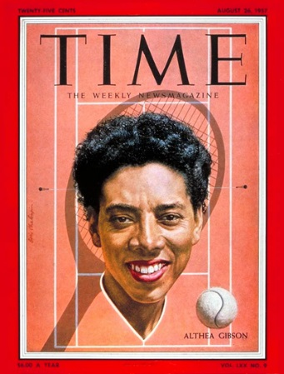

Althea Gibson Biography
Golfer, Tennis Player, Athlete (1927–2003)

Synopsis
Althea Gibson was born in South Carolina on August 25, 1927. At an early age, she developed a love of sport. Her great talent was in tennis, but in the 1940s and '50s, most tournaments were closed to African Americans. Gibson kept playing (and winning) until her skills could no longer be denied, and in 1951, she became the first African American to play at Wimbledon. Gibson won the women's singles and doubles at Wimbledon in 1957, and won the U.S. Open in 1958.

Early Life
Althea Neale Gibson was born on August 25, 1927, in Silver, South Carolina. Gibson blazed a new trail in the sport of tennis, winning some of the sport's biggest titles in the 1950s, and broke racial barriers in professional golf as well. At a young age, Gibson moved with her family to Harlem, a neighborhood in the borough of New York City. Gibson's life at this time had its hardships. Her family struggled to make ends meet, living on public assistance for a time, and Gibson struggled in the classroom, often skipping school all together. However, Gibson loved to play sports—especially table tennis—and she soon made a name for herself as a local table tennis champion. Her skills were eventually noticed by musician Buddy Walker, who invited her to play tennis on local courts.
After winning several tournaments hosted by the local recreation department, Gibson was introduced to the Harlem River Tennis Courts in 1941. Incredibly, just a year after picking up a racket for the first time, she won a local tournament sponsored by the American Tennis Association, an African-American organization established to promote and sponsor tournaments for black players. She picked up two more ATA titles in 1944 and 1945. Then, after losing one title in 1946, Gibson won 10 straight championships from 1947 to 1956. Amidst this winning streak, she made history as the first African-American tennis player to compete at both the U.S. National Championships (1950) and Wimbledon (1951).

Making History
Gibson's success at those ATA tournaments paved the way for her to attend Florida A&M University on a sports scholarship. She graduated from the school in 1953, but it was a struggle for her to get by. At one point, she even thought of leaving sports all together to join the U.S. Army. A good deal of her frustration had to do with the fact that so much of the tennis world was closed off to her. The white-dominated, white-managed sport was segregated in the United States, as was the world around it.
The breaking point came in 1950, when Alice Marble, a former tennis No. 1 herself, wrote a piece in American Lawn Tennis magazine lambasting her sport for denying a player of Gibson's caliber to compete in the world's best tournaments. Marble's article caught notice, and by 1952—just one year after becoming the first black player to compete at Wimbledon—Gibson was a Top 10 player in the United States. She went on to climb even higher, to No. 7 by 1953.
In 1955, Gibson and her game were sponsored by the United States Lawn Tennis Association, which sent her around the world on a State Department tour that saw her compete in places like India, Pakistan, and Burma. Measuring 5-feet 11-inches, and possessing superb power and athletic skill, Gibson seemed destined for bigger victories. In 1956, it all came together when she won the French Open. Wimbledon and U.S. Open titles followed in both 1957 and 1958. (She won both the women's singles and doubles at Wimbledon in 1957, which was celebrated by a ticker tape parade when she returned home to New York City.) In all, Gibson powered her way to 56 singles and doubles championships before turning pro in 1959.
For her part, however, Gibson downplayed her pioneering role. "I have never regarded myself as a crusader," she states in her 1958 autobiography, I Always Wanted to Be Somebody. "I don't consciously beat the drums for any cause, not even the negro in the United States."

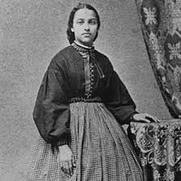
Mary Jane Patterson Biography
Educator (c. 1840–1894)

Synopsis
Born in Raleigh, North Carolina in 1840, Mary Jane Patterson became the first African-American woman to receive a college degree when she graduated from Oberlin College in 1862. The daughter of fugitive slaves, she went on to have an illustrious career as an educator and was known to be a mentor to many African Americans.

Life & Legacy
Mary Jane Patterson was born in Raleigh, North Carolina in 1840. She is believed to be the oldest of seven children, and that her parents, Henry Irving and Emeline Eliza Patterson, were fugitive slaves. In 1852, her family left Raleigh and moved to Oberlin, Ohio in 1856, in hopes that the children would be able to get a college education. Growing up, her father -- a childhood friend of Andrew Johnson -- supported the family through his work as a skilled mason. To help make ends meet, the family also boarded black students.
In 1835, Oberlin College admitted its first black student and two years later became the country’s first coed institution of higher education. It was also the first college in the country to grant undergraduate degrees to women. These changes paved the way for Mary Jane Patterson, who studied for a year in the college’s Preparatory Department. There were still only a few black students enrolled at the college during her four years leading to her graduation in 1862. By earning her B.A., Patterson became the nation’s first African-American woman to receive a bachelor’s degree. (Patterson’s brother, John, and her sisters Emma and Chanie Ann, all would graduate from Oberlin and go on to pursue teaching careers.)
After graduation, Mary Jane Patterson taught at the Institute for Colored Youths in Philadelphia, then accepted a teaching position in Washington D.C at the Preparatory High School for Colored Youths. In 1871, she became the first black principal of the newly-founded Preparatory High School for Negroes. Over the course of her career, she was known to be a mentor to many African-American women. She continued working at the school until her death on September, 24 1894.

George Washington Carver

Synopsis
George Washington Carver was born into slavery in Diamond, Missouri, around 1864. The exact year and date of his birth are unknown. Carver went on to become one of the most prominent scientists and inventors of his time, as well as a teacher at the Tuskegee Institute. Carver devised over 100 products using one major crop—the peanut—including dyes, plastics and gasoline. He died in 1943.

Early Years
Botanist and inventor George Washington Carver was one of many children born to Mary and Giles, an enslaved couple owned by Moses Carver. He was born during the Civil War years, most likely in 1864. A week after his birth, George was kidnapped along with his sister and mother from the Carver farm by raiders from the neighboring state of Arkansas. The three were sold in Kentucky, and among them only the infant George was located by an agent of Moses Carver and returned to Missouri.
The conclusion of the Civil War in 1865 brought the end of slavery in Missouri. Moses Carver and his wife, Susan, decided to keep George and his brother James at their home after that time, raising and educating the two boys. Susan Carver taught George to read and write, since no local school would accept black students at the time.
The search for knowledge would remain a driving force for the rest of George's life. As a young man, he left the Carver home to travel to a school for black children 10 miles away. It was at this point that the boy, who had always identified himself as "Carver's George" first came to be known as "George Carver." Carver attended a series of schools before receiving his diploma at Minneapolis High School in Minneapolis, Kansas.
Accepted to Highland College in Highland, Kansas, Carver was denied admittance once college administrators learned of his race. Instead of attending classes, he homesteaded a claim, where he conducted biological experiments and compiled a geological collection. While interested in science, Carver was also interested in the arts. In 1890, he began studying art and music at Simpson College in Iowa, developing his painting and drawing skills through sketches of botanical samples. His obvious aptitude for drawing the natural world prompted a teacher to suggest that Carver enroll in the botany program at the Iowa State Agricultural College.
Carver moved to Ames and began his botanical studies the following year as the first black student at Iowa State. Carver excelled in his studies. Upon completion of his Bachelor of Science degree, Carver's professors Joseph Budd and Louis Pammel persuaded him to stay on for a master's degree. His graduate studies included intensive work in plant pathology at the Iowa Experiment Station. In these years, Carver established his reputation as a brilliant botanist and began the work that he would pursue for the remainder of his career.

Rise to Prominence
Carver's work at Tuskegee included groundbreaking research on plant biology that brought him to national prominence. Many of these early experiments focused on the development of new uses for crops such as peanuts, sweet potatoes, soybeans and pecans. The hundreds of products he invented included plastics, paints, dyes and even a kind of gasoline. In 1920, Carver delivered a speech before the Peanut Growers Association, attesting to the wide potential of peanuts. The following year, he testified before Congress in support of a tariff on imported peanuts. With the help of Carver's testimony, Congress passed the tariff in 1922.
Carver's prominence as a scientific expert made him one of the most famous African-Americans and one of the best-known African-American intellectuals of his time. By the time of his testimony, however, Carver had already achieved international fame in political and professional circles. President Theodore Roosevelt admired his work and sought his advice on agricultural matters in the United States. Carver was also recognized abroad for his scientific expertise. In 1916, he was made a member of the British Royal Society of Arts—a rare honor for an American. Carver also advised Indian leader Mahatma Gandhi on matters of agriculture and nutrition.
Carver used his celebrity to promote scientific causes for the remainder of his life. He wrote a syndicated newspaper column and toured the nation, speaking on the importance of agricultural innovation, the achievements at Tuskegee, and the possibilities for racial harmony in the United States. From 1923 to 1933, Carver toured white Southern colleges for the Commission on Interracial Cooperation.
The politics of accommodation championed by both George Washington Carver and Booker T. Washington were anathema to activists who sought more radical change. Despite his involvement with government-funded scientific research and programs, Carver largely remained outside of the political sphere, and declined to criticize prevailing social norms outright. Nonetheless, Carver's scholarship and research contributed to improved quality of life for many farming families, and made Carver an icon for African-Americans and Anglo-Americans alike.
George Washington Carver died on January 5, 1943, at the age of 78 after falling down the stairs at his home. He was buried next to Booker T. Washington on the Tuskegee grounds. Carver's epitaph reads: "He could have added fortune to fame, but caring for neither, he found happiness and honor in being helpful to the world."

