Name:___________________________________________________ Date:________________________________________________________-

**Map of Southwest Asia**

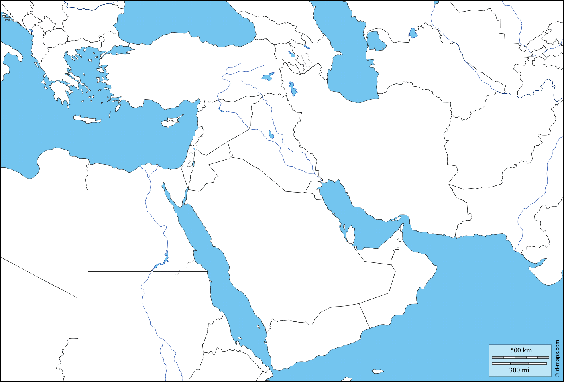

**Label each country and physical feature and color the map according to verbal directions form your teacher. (Countries are underlined)**

Afghanistan United Arab Emirates (UAE) Qatar Yemen Mediterranean Sea Suez Canal Black Sea

Iran Saudi Arabia Kuwait Oman Tigris River Arabian Sea

Iraq Syria Turkey Jordan River Euphrates River Strait of Hormuz

Lebanon Israel Jordan Red Sea Persian Gulf West Bank