New South, WW1 & WW2 Study Guide Answer Key
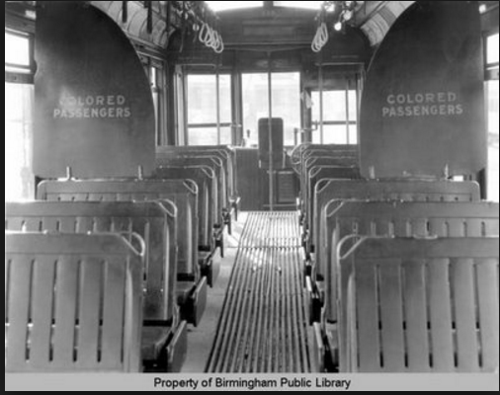
1. Look at the picture above. Which court case ruling made this act legal?
Plessy v. Ferguson

2. Why was Henry Grady known as the “voice of The New South”?
In his articles, he said that GA needed to move from agriculture toward industries.

3. What was the result of the passage of “Jim Crow” laws?
Separate restrooms, water fountains, railroad cars, dining areas and schools

4. What was the main purpose of the International Cotton Exposition?
To showcase the industries in the New South.

5. What GA leader based his career on supporting poor farmers, on a platform of lower taxes?
Tom Watson

6. Who replaced Tom Watson in Congress after he died while still serving his term?
Rebecca Latimer Felton

7. The cause of the 1906 Race Riot in Atlanta was caused by
A series of articles in the newspaper about black violence against white women

8. Who was accused of killing Mary Phagan at the pencil factory on April 26, 1913?
Leo Frank

9. How did the county unit system affect voting and politics in Georgia in the early 1900’s?
It gave rural areas more political power.

10. How did the Bourbon Triumvirate describe the New South Period?
A blending of the new and the old, keeping old southern traditions while building new traditions around industries to rival the North.

11. Whose rights did Tom Watson and the Populists fight for?
Rural Farmers

12. 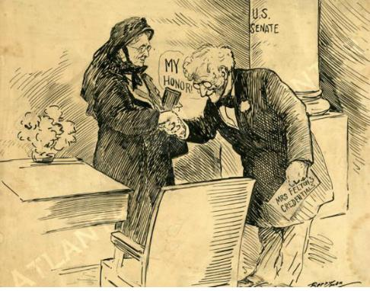
What is the subject of the political cartoon?
Rebecca Latimer Felton serving as a United States senator.

13. Due to the lack of enforcement by the federal government, southern states established many laws that prevented blacks, and poor whites from voting. This is called
Disenfranchisement

14. What Constitutional amendment(s) was violated by Jim Crow legislation?
14th & 15th Amendment

15. In 1920, the Nineteenth Amendment to the U.S. Constitution was ratified. How did this amendment change the make-up of those who could vote in Georgia? (SS8H7b)
It allowed women to vote

16. What did Booker T. Washington believe about social equality among blacks and whites of his day?
He accepted social separation and felt that African Americans could advance faster through hard work than by demanding equal rights.
17. What did DuBois believe about social equality among blacks and whites of his day?
He felt that African Americans should speak out against discrimination and that college-educated African Americans should lead the fight against it.
18. Who was selected as the first black president of both Morehouse and Atlanta University?
John Hope

19. What organization did Lugenia Burns Hope establish?
Neighborhood Union

20. What business made Alonzo Herndon a successful businessman?
Atlanta Mutual Insurance Company

21. What led to the decision for the United States to enter World War I?
The sinking of the Lusitania, Zimmerman telegram & submarine attacks on US ships

22. World War I begins with ________________ and ends with the signing of____________.
Assassination of Archduke Franz Ferdinand and Treaty of Versailles

23. Why was Georgia important to the World War 1 effort?
Many US Soldiers trained in Georgia training camps.

24. What caused cotton production to drop from 1.75 million bales in 1914 to 588,000 bales in 1923?
A small long-snouted beetle called the boll weevil destroyed cotton in the field.
25. This insect caused cotton production to drop and on the hills of that GA suffered a severe _______________ that made farmers pack up and move.

Drought

26. Which U.S. President believed in the practice of laissez-fair policies that helped bring about the depression in the 30s?
Herbert Hoover
* * Borrowing more money than could be repaid
* Speculating in the Stock Market
* Overproducing farm products
These events led to_______?
The Great Depression

27.

28. What programs were apart of Roosevelt's "New Deal"?
Agricultural Adjustment Act (AAA)
Civilian Conservation Corps (CCC)
Social Security Act (SSA)
Rural Electrification Authority (REA)
29. Place the following events in the correct chronological order they occurred:
1. Sharp economic growth -1920’s
2. Drought and Dust Bowl-1930’s
3. Black Tuesday-1929
4. World War I-1914-1918
4, 1, 3, 2

30. Eugene Talmadge became governor of Georgia in 1933. He disliked relief efforts, public welfare and debts. As a result of these beliefs, Governor Talmadge
Tried to get rid of all of the New Deal programs in Georgia.

31. The Civilian Conservation Corps (CCC) was a popular New Deal program because it put unemployed people to work during the Depression. What was a result of the CCC?
Many men across Georgia and the U.S. built public facilities, many of which exist to this day.
32. What was the name of the federal assistance program designed to bring economic relief during the Great Depression?
The New Deal
33. What president was responsible for creating the programs that would bring economic relief during the Great Depression?
Franklin D. Roosevelt

34. What program loaned money to farmer's cooperatives to help them build power lines and purchase power wholesale?
Rural Electrification Administration

35. What New Deal program restricted agricultural production by paying farmers to grow fewer crops?
Agricultural Adjustment Act

36. The purpose of Social Security is to
Create a system of retirement and unemployment benefits

37. What act encouraged Georgia’s farmers to stop relying solely on cotton, and to plant peanuts, corn, tobacco, and other crops?
AAA

38. A major difference between the New Deal and the policies followed by earlier administrations was that the New Deal
Provided the government with a more active role in the economy

39. What caused the United States to get involved in World War II?
The Japanese bombed Pearl Harbor in Hawaii.
40. What describes the involvement of the United States in WWII before the bombing of Pearl harbor?
The US provided lend-lease aid to Great Britain and the Soviet Union.

41. This term means to give into the demands of an aggressor in order to avoid war.
Appeasement

42. Why was Carl Vinson recognized by two United States presidents?
He was a major influence in promoting the US to strengthen its navy before & after WWII.

43. What was the name of the Marietta factory used to build B-29 bombers during WWII?
Bell Aircraft

44. Richard B. Russell helped to bring 15 __________ to GA
Military bases

45. During World War II, the Georgia cities of Savannah and Brunswick were BEST known for
Building Liberty ships.

46. In what way did Georgia contribute to the Allies during World War II?
1. Six-hundred bomber airplanes (Bell Bomber) were built in Marietta and used in WWII.
2. Ships were built in both Savannah and Brunswick, which were used in WWII.
3. Carl Vinson and Richard Russell had several military bases built in Georgia during WWII.

47. The systematic killing of 6 million Jewish people by the Nazis was known as the
Holocaust.

48. President Franklin Delano Roosevelt’s Little White House was in Warm Springs, Georgia. Why did the president often travel to Georgia?
President Roosevelt suffered from polio and swam in the healing water of Warm Springs.

49. A ruler with total power over a country who has typically obtained power by force.
Dictator

50. The national policy of abstaining (sitting out) from political or economic relations with other countries.
Isolationism

